Dissertation Research Proposal:

*Leaf to Canopy Functional Resilience:*

*Plant physiological and carbon cycling stability following disturbance*

Student: Lisa T. Haber

VCU Integrative Life Sciences

Advisor: Chris Gough

VCU Department of Biology

Revised September 17, 2021

**Introduction and Motivation:**

Ecological disturbances impact core ecosystem functions, including production and biogeochemical cycling, by precipitating changes in biodiversity, vegetation structure, and functional trait distributions (Connell, 1978; Mouillot et al., 2013; Sousa, 1984). As disturbance patterns intensify and abruptly transition to novel regimes under global change, future trajectories of ecosystem functions, including carbon (C) uptake and storage, are uncertain (Johnstone et al., 2016; Thom & Seidl, 2016). A more complete understanding of the mechanisms underpinning ecosystem stability, including the magnitude of initial change (*resistance*; Hillebrand et al., 2017) and the rate of return (*resilience*; ibid.) to pre-disturbance functioning following disturbance, is needed to forecast future C cycling.

Replicated ecosystem-scale disturbance experiments, particularly when coupled with modeling, are required to rigorously test hypothesized trajectories of ecosystem structural and functional change following disturbance and to yield greater insight into the mechanistic basis for stability (Amiro et al., 2010; Hicke et al., 2012). The NSF-funded Forest Resilience Threshold Experiment (FoRTE), which is currently underway at the University of Michigan Biological Station in northern Lower Michigan, is one such experiment aimed at disentangling and mechanistically understanding the drivers of temperate forest stability in response to simultaneous successional change and moderate-severity disturbance. FoRTE presents a valuable opportunity to research how ecosystem structural and functional attributes both respond to disturbance and mediate disturbance impacts on C cycling across a replicated gradient of disturbance severity. The specific focus of my research is understanding the role that leaf functional traits (i.e. morphological, biochemical, and physiological characteristics controlling function and conferring fitness) play in supporting ecosystem C cycling resistance and resilience.

Leaf functional traits, including both intra- and interspecific variability and plasticity, regulate whole-canopy photosynthetic response to disturbance, as surviving trees are poised to acquire and use the resources that senescing trees no longer take up (Gough et al., 2013; Nave et al., 2011). Moreover, leaf functional trait distributions are important to constrain for ecosystem modeling of the C cycle, and constitute highly influential model parameters that also often contribute substantial uncertainty to model predictions (Shiklomanov et al., 2020). Although leaf functional trait distributions have been extensively characterized in global databases such as TRY (Kattge et al., 2011), few studies have examined how these distributions change along gradients of disturbance severity and whether these changes affect model forecasts of C cycling response to disturbance (Bernhardt-Römermann et al., 2011; Turner et al., 1998).

This dissertation proposal aims to leverage the multi-faceted FoRTE project as well as an ongoing Virginia-based wetland restoration project to address four interrelated thematic questions: (1) How does rapid physiological, biochemical, and morphological response to disturbance in upper and lower forest canopy strata support ecosystem functional stability, and when does stability decline?, (2) Within the “released” subcanopy stratum following disturbance, how do leaf functional traits support production stability across the severity continuum?, (3) Is the representation of dynamic leaf functional traits necessary to accurately capture C cycling response to disturbance in ecosystem models?, and (4) What are the principal physical and ecological drivers of post-disturbance aboveground C cycling recovery in an understudied wetland ecosystem? Broadly, my dissertation will improve understanding of the mechanisms governing ecosystem C cycling stability following disturbance, with dual focus on observations and modeling. My personal goals for knowledge and skill acquisition also include gaining experience working in more than one ecosystem (temperate forest and freshwater tidal wetland) and observational platform (ground-based vs. eddy covariance characterization of plant function and ecosystem-scale production), as well as developing skills in model-data integration and ecosystem forecasting approaches.

**Chapter 1:** *Ecophysiological stability across a gradient of disturbance severity*

**1.1 Introduction**

Forest production resilience to disturbance depends in part on the capacity of surviving trees to efficiently acquire and use resources such as light, nitrogen (N), and water for which senescing neighbors no longer compete (Nave et al., 2011). As disturbances become more frequent and spatially extensive across the temperate biome of North America (Cohen et al., 2016), understanding the impacts of spatially heterogeneous tree mortality on forest C cycling is timely. Variation in the distribution and timing of tree senescence constrains access to liberated resources, and can be an important environmental driver to capture in modeling forest production response (Dietze & Matthes, 2014). Additionally, differences in the leaf functional traits, including ecophysiological plasticity and leaf biochemistry, of dominant plant functional types (PFTs) within the forest matrix may influence growth of surviving trees following disturbance (Bernhardt-Römermann et al., 2011).

The unique neighborhoods occupied by trees, which differ in both biological (e.g. PFT and/or functional trait diversity) and structural (e.g. size of neighbors, stem density) characteristics, may impact trees’ functional response to disturbance with implications for production resilience (Grossiord, 2019; Uriarte et al., 2004). Here, the term “neighborhood” refers to individual trees’ zones of ecological influence (Addicott et al., 1987), where we hypothesize that dynamic leaf functional and biochemical response – and concomitant stability of C uptake – may be linked to resource redistribution resulting from disturbance. More biodiverse and more structurally complex neighborhoods can more efficiently use available resources such as light and N than simpler, less diverse ones. As a result, we expect variability in neighborhood biological and structural characteristics to influence stability of C cycling (Cardinale et al., 2012; Paquette & Messier, 2011). Inter- (Haddad et al., 2008) and intra-specific (Ali et al., 2017) plant functional trait diversity has been correlated with ecosystem functional stability following disturbance. Moreover, leaf functional trait assemblages within and across PFTs are sensitive to disturbance, making some leaf functional traits both a driver of and response variable to environmental change (Garnier et al., 2016).

In this study, I will use repeated canopy leaf ecophysiological and morphological sampling of trees, each within a unique neighborhood and exposed to one of four disturbance severities, to probe whether, and when, dynamic leaf physiology is supported following experimental disturbance by a combination of trait plasticity and neighborhood-scale structure. At the Forest Resilience Threshold Experiment (FoRTE) site in northern Michigan, I will focus on three widespread canopy dominant tree species representing two PFTs: bigtooth aspen (*Populus grandidentata*), an early successional temperate broadleaf species, as well as red maple (*Acer rubrum*) and Northern red oak (*Quercus rubra*), two mid- to late-successional species. Following induced disturbance – in the form of stem girdling – across a severity gradient from 0 – 85 % leaf area loss, I will examine intra- and interspecific distributions of leaf functional traits with demonstrated sensitivity to disturbance (Kumordzi et al., 2019; Schafer et al., 2014) in order to characterize disturbance-precipitated physiological response across the canopy stratum. Prior work at our experimental site has indicated that moderate-severity disturbance does not precipitate extensive N leaching. In the FASET disturbance manipulation, which involved stem girdling of all early successional aspen and birch trees across 33 hectares, uptake of available N by later successional species including maples and oaks led to N enrichment of canopy leaves (Nave et al., 2011), providing a potential mechanism linking disturbance to leaf functional traits to ecosystem production. I will use a finely detailed stem map data set to delineate tree neighborhoods for each sampled stem, in order to characterize local environmental heterogeneity that may contribute to canopy leaf function and ecosystem production response.

**1.2 Objectives & Hypotheses:**

**O1.1:** Characterize differences in the crown-level means of key biochemical (inferred from leaf reflectance as the normalized difference vegetation index), physiological (light-saturated photosynthetic rate, stomatal conductance), and morphological (leaf mass per area) variables for trees subjected to differing levels of neighborhood disturbance severity.

***H1.1:*** *In surviving tree crowns, increased leaf N content (Nave et al., 2011) will lead to enhanced normalized difference vegetation index (NDVI), leaf-level photosynthetic rate (Asat), stomatal conductance (gs), and leaf mass per area (LMA) across the first three growing seasons following stem girdling. The magnitude of this enhancement will be greatest at the highest degrees of disturbance (85 % canopy LAI loss), where neighboring tree senescence will produce a larger pool from which surviving trees may extract resources.*

**O1.2:** Compare intra- and interspecific leaf functional plasticity for crowns of three different species included in the study: red maple (*Acer rubrum*), bigtooth aspen (*Populus grandidentata*), and Northern red oak (*Quercus rubra*).

***H1.2:*** *Later successional species (A. rubrum and Q. rubra) subjected to identical disturbance severities as the aging early successional aspen will experience greater leaf N increase and enhanced physiological response (Asat), as these species are physiologically poised to become canopy dominants against the broader regional backdrop of declining early successional species (Wolter & White, 2002). Although all crowns were sampled at similar pre-disturbance within-canopy light conditions, crowns of smaller trees will physiologically outperform those of larger conspecific trees following well-established age- and size-related trends for temperate forest trees (Meinzer et al., 2011)*.

**O1.3:** Determine whether and how tree neighborhoods’ structural and biological characteristics correlate with leaf ecophysiological plasticity in response to disturbance.

***H1.3:*** *Focal trees in neighborhoods at the higher end of the disturbance severity gradient (i.e. with fewer surviving neighbors) will exhibit greater increases in crown-level mean leaf physiological and reflectance variables from pre-disturbance to two years post-disturbance due to decreased competition for resources. However, the impact of reduced competition will be mediated both by structural (size class) and biological (species) diversity of neighborhoods. Size asymmetries between focal trees and their neighbors will be greatest at the highest disturbance severity (where nearly all survivors are small trees due to the “top-down” elimination of neighboring basal area), further enhancing focal trees’ access to liberated resources (DeMalach et al., 2016). In neighborhoods with greater species diversity, niche complementarity will also enhance focal trees’ ability to access resources relative to less diverse neighborhoods at the same disturbance severity and/or similarly diverse neighborhoods in the control plot (Fargione et al., 2007).*

**1.3 Methods:**

*1.3.1 Experimental design and site description*

This study is currently underway at the Forest Resilience Threshold Experiment (FoRTE) at the University of Michigan Biological Station (UMBS) in northern Lower Michigan. FoRTE is an NSF-funded ecosystem-scale disturbance manipulation probing the mechanisms controlling forest net primary production (NPP) resistance and resilience across a replicated gradient of disturbance severity and between two contrasting disturbance types. A suite of data describing both above- and belowground ecosystem structure and function were collected in 2018, prior to disturbance initiation. In May 2019, approximately 3,750 stems ≥ 8cm diameter at breast height across 8 hectares of century-old forest were stem girdled (Fig. 1.1), a process which involves cutting and removal of the bark and phloem tissue around the circumference of the stem in order to disrupt carbon transport from a tree’s crown to roots, thereby killing the tree over one to several years (Rademacher et al., 2019). FoRTE girdling-induced disturbance includes two treatment types targeting the largest and smallest stems (“top-down” and “bottom-up” treatments, respectively). Within FoRTE, 4 replicates of 4 plots each were established and treated, including control (0 %) as well as 45, 65, and 85 % disturbance severities (as targeted leaf area loss), for a total of 16 plots (Fig. 1.2, Table 1.1). Each plot was divided in half and the top-down and bottom-up treatments were implemented in different halves, with 32 individual 0.1 hectare subplots created for intensive data collection (see Fig. 1.2). Measurements including leaf functional traits, physiology, and above-ground NPP continued in 2019 and 2020, and are planned for summer 2021, as described in detail below.

This study takes place within a single FoRTE replicate (“D”) where a preexisting two-track road allows for vehicular access using UMBS’s Zero Emissions Canopy Access Vehicle, or “Zeke”. Zeke is a drivable lift vehicle designated for research of canopy processes at UMBS, including gas fluxes, and features a 60-foot telescoping boom and platform that enables direct measurements within the canopy stratum.

*1.3.2 Canopy leaf functional traits and physiology*

Crowns of focal trees (i.e. those trees selected for sampling) were sampled at maximum leaf-out prior to disturbance in summer 2018, 2019, and 2020, and will be sampled again in at maximum leaf-out in 2021. Sampling density was as follows: 3 leaves per crown x 6 crowns per species x 3 species = 54 leaves per plot, across 4 plots (72 crowns and 216 leaves total). Mature trees, located inside plot boundaries, with emergent crowns (i.e. not understory trees) were chosen wherever available; however, some focal trees outside of experimental plot boundaries were included based on accessibility from Zeke. Intact, healthy, sun-adapted leaves were selected from three locations in each crown, and each leaf was located on a different terminal branch of the tree. Since our sampling targeted only three tree species and only individuals with emergent crowns, focal trees were haphazardly located, sometimes within just a few meters of other focal trees and sometimes further away (see Figure 1.3).

Maximum rate of light-saturated photosynthesis (Asat), stomatal conductance (gs), and related measurements were made with a LI-6400 XT portable photosynthesis system (LI-COR Inc., Lincoln, NE). Leaf reflectance, used as a proxy for leaf biochemistry (including N content), was measured with a CI 710 miniature leaf spectrometer (CID Biosciences, Camas, WA). Multiple spectral indices are generated from a single leaf reflectance spectrum, including the normalized difference vegetation index (NDVI), a widely used metric of plant greenness, chlorophyll content and % N. A strong correlation between NDVI and % N (r2 = 0.89 in spring and 0.82 in fall) was found in a recent study in the northern temperate Harvard Forest (Yang et al., 2017), suggesting that NDVI is likely a useful proxy for % N in FoRTE. Leaf mass per area (LMA) was measured by collecting leaves, scanning their area with an LI-3100 leaf area meter (LI-COR Inc.), drying at 60 °C for several days, and weighing to determine mass.

*1.3.3 Aboveground wood biomass accumulation*

Dendrometer bands, enabling measurement of fine-scale woody biomass growth over time, were installed on each focal tree prior to disturbance in 2018. These bands were read in November 2018, and during and after the growing season in both 2019 and 2020. They will continue to be read in 2021 to determine aboveground woody biomass accumulation for each focal tree, allowing for inference to be made about aboveground tree growth in connection with crown leaf function.

*1.3.4 Stem mapping, girdling, and ecological neighborhoods*

In 2019, stems of trees (≤ 8 cm DBH) within a 10 m radius of the base of focal trees (i.e. within 2 average crown diameters for this forest; (Hardiman et al., 2017) were mapped to delineate ecological neighborhoods. I reasoned that while demarcation of a tree’s “neighborhood” is arbitrary, an individual tree’s ecological impacts diminish with increasing distance from the stem. A radius of two crown diameters (i.e. 10 m) around a focal tree will include that tree’s immediate canopy-emergent neighbors, whose influence on focal tree physiology and growth I aim to characterize in this study. Prior studies of neighborhood effects on tree growth in temperate forests have used variable neighborhood sizes, with at least two studies identifying a 10 m radius neighborhood as an appropriate spatial scale (Fan et al., 2020; Frelich et al., 1998).

A subset of mapped trees was selected for girdling following the top-down disturbance treatment protocol, in which trees are ranked by their LAI (from largest to smallest) and then girdled in that order until the desired disturbance severity is reached. We employed only the top-down treatment type in this study in order to target canopy dominant and subdominant trees (i.e. the same canopy stratum occupied by focal trees). All focal trees were excluded from girdling, since the goal of the study is to determine whether and how surviving tree crowns respond to neighborhood disturbance; however, accidental girdling of two focal trees reduced the sample size to 70 stems. Girdling took place at the same severities employed in the background FoRTE manipulation, i.e. 0, 45, 65, and 85 % gross defoliation (see Fig. 1.4 for an example).

Based on my species-specific study objectives and interest in neighborhood effects, and due to sampling constraints, only a subset of trees in the study area were both accessible and fit the sampling criteria. Due to the natural, irregular spatial arrangement of focal trees in this study, their 10 m-radius ecological neighborhoods frequently overlap and intersect, and as a result are likely to be a spatially autocorrelated predictor of crown physiology and tree growth. I address the issue of spatial autocorrelation explicitly in the next section.

*1.3.5 Statistical analysis*

I will use a series of spatially-explicit Bayesian hierarchical models to analyze the influence of neighborhood attributes (neighboring tree sizes, species identities, and spatial orientation) as well as time (i.e., year) on focal tree physiological and morphological variables of interest. The individual tree crown (i.e., the mean value for each crown from three sampled leaves within the crown) is the experimental unit considered in all models (and denoted in the model by subscript *i*). I am choosing to use a Bayesian modeling framework because it confers several advantages over frequentist spatial modeling approaches in this study. First, it will allow for flexibility in prior distribution assignments for modeled variables, reflecting the reality of (in some cases) non-normally distributed parameters (DBH and disturbance severity). Second, Bayesian hierarchical modeling frameworks are increasingly used in similar spatially explicit ecological analyses, and there is growing precedent in the literature for use of these techniques (Banner et al., 2020; Fortin & Dale, 2005; Hooten et al., 2015). Third, Bayesian hierarchical models allow for an explicit assessment of parameter uncertainty, which may prove useful both in this study and in decision making about future study designs within the ongoing FoRTE project.

To address my interrelated and explicitly spatial questions, I will use the model outlined below (and described in detail following the series of component equations). Subscript notation is used throughout the model structure to index values for variables as follows: *i* denotes the *i*th tree crown in the sampled population of 70 focal trees; *j* indexes the year of observation in the four-year timeframe from 2018-2021; and *k* indicates the *k*th species in the set of three tree species included in this analysis (red maple, red oak, and bigtooth aspen):

(1.1)

(1.2)

(1.3)

(1.4)

(1.5)

(1.6)

(1.7)

(1.8)

(1.9)

(1.10)

(1.11)

(1.12)

(1.13)

(1.14)

(1.15)

(1.16)

) (1.17)

(1.18)

(1.19)

(1.20)

Where yijk is the crown-level outcome of interest (leaf Asat, gs, LMA, NDVI; 1.1); µijk is the modeled mean (1.2); α is the intercept term with a flat prior (1.3); are regression coefficients for the continuous and categorical variables of interest (1.4 – 1.16); DBHi is a continuous variable, the tree’s diameter at breast height; Severityi is disturbance severity (i.e. the fraction of neighboring tree basal area that has been girdled, from 0 to 0.85, also a continuous variable); Hi is the continuous variable of basal area-weighted Shannon’s biodiversity index for the focal tree’s neighborhood; X1k and X2k are “dummy” or binary variables for the categorical variable of tree species with three levels (one for each of the three focal tree species included in this study) and each have a corresponding regression coefficient; year (each of the four years of measurement, 2018-2021, which can differ substantially in terms of climatic variables and therefore do not necessarily have a linear relationship) is also treated in this model as a categorical variable, and represented with the three binary variables Y1, Y2, and Y3; Severityi*Y1j, Severityi*Y2j, Severityi*Y3j, Severityi*X1k, and Severityi*X2k are the two-way interactions of ecological interest in this study between disturbance severity and year (represented by dummy variables Y1, Y2, and Y3), and disturbance severity and species (X1 and X2); vi is a jointly specified spatially-correlated random effect term with multivariate normal distribution and precision matrix (1.17); and is the residual error term. Including vi allows for incorporation of spatial-autocorrelation in the model and will allow for analysis of the influence of other variables in light of spatial autocorrelation. The jointly specified spatial random effect term vi incorporates a spatial dependence structure such that the closer in space two trees are (i.e. the smaller the distance between them, denoted by dij; 1.18), the more similar their expected values of yijk will be. The correlation between trees declines with increasing distance, as described by the powered exponential decay function (1.18). Parameters phi (1.19) and kappa (1.20) are scalar parameters controlling the powered decay function. The Gaussian prior distributions specified for the coefficients (betas in the above model; 1.4 – 1.16) are selected as uninformative.

Specification of prior distributions for Bayesian data analysis is an area of active debate in ecology (Banner et al., 2020), with some ecological modelers preferring to specify uninformative priors even when prior knowledge is available. To assess the impact on posterior distributions of my modeled variables, I will complete a sensitivity analysis using different choices of prior distribution for my fixed effect terms (betas in the model above; 1.4 – 1.10).

**1.4** **Progress to date**

To date, I have collected three years’ worth of data in the same 70 tree crowns and mapped all stems within each focal tree’s neighborhood. These physiological, morphological, and reflectance data will be made freely available through the recently published *fortedata* package in R (Atkins et al., 2021). Following my final season of data collection this summer, I will complete my statistical analysis.

Nonindependence of samples complicates statistical comparison of sample leaf functional traits across species and disturbance severities. However, it is useful to visualize the data prior to statistical analysis in order to get a sense of central tendency, variance, and emerging patterns and trends through time. Figures 1.5 and 1.6 display boxplots of light-saturated leaf photosynthetic rate (Asat) across the existing three years’ worth of collected data (2018 – 2020) grouped by disturbance severity and focal tree species, respectively. Broadly speaking, there appear to be differences in leaf-level physiology emerging across years (likely attributable to interannual climatic variability), disturbance severities (Fig. 1.5), and species (Fig. 1.6), in keeping with my hypotheses in this study.

**1.5 Figures and Tables**

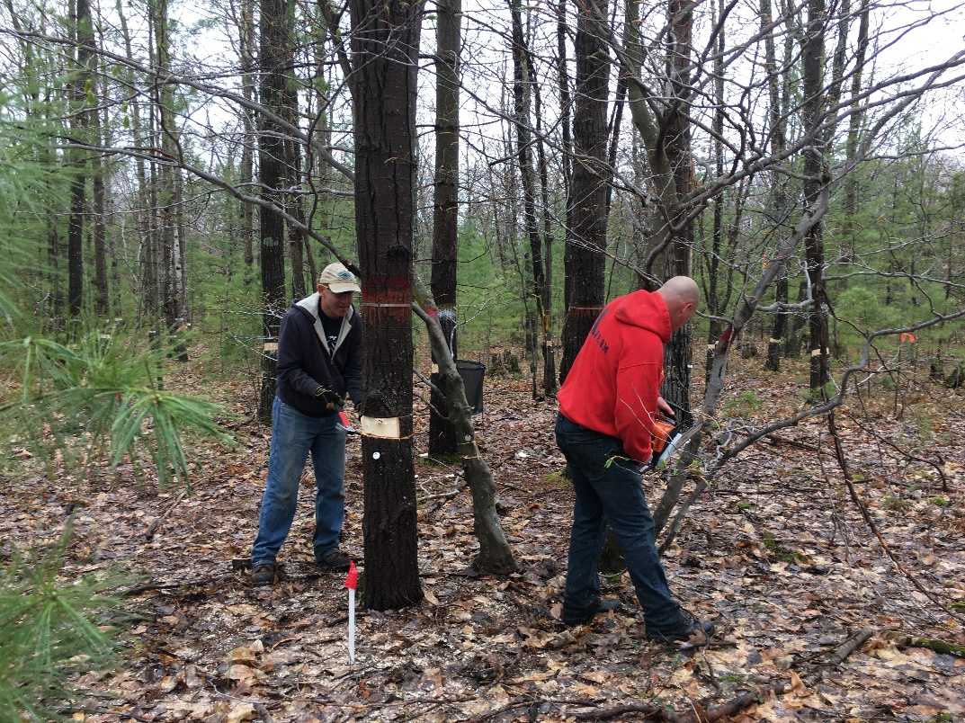

**Figure 1.1**. Stem girdling within the FoRTE manipulation in May, 2019. At left, project co-PI Ben Bond-Lamberty is using a prybar and hammer to remove a strip of bark and phloem tissue from the stem of a bigtooth aspen, following the chainsaw cutting of two parallel rings around the stem. At right, a sawyer is cutting these rings into a small American beech tree.

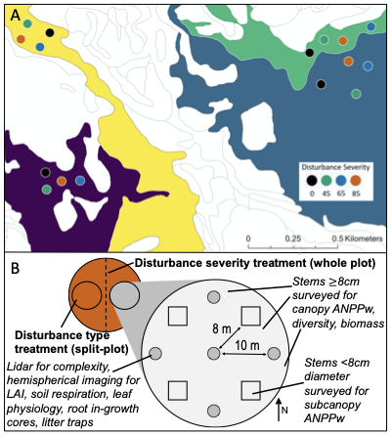

**Figure 1.2.** Map of the Forest Resilience Threshold Experiment (FoRTE) experimental plots (A) and diagram of the FoRTE split-plot treatment design (B). Experimental replicates (groups of four differently colored circles) are distributed across four distinct landscape ecosystem types (purple, yellow, blue, and green shaded areas) according to the UMBS classification system (Pearsall et al., 1995). Within each replicate, plots with disturbance severities ranging from 0 to 85 % are included. Each plot is further subdivided into halves where two contrasting disturbance types (top-down and bottom-up) are implemented. Data types are collected in different locations within each subplot (smaller circles within each plot half; 32 across FoRTE). This study will take place within the “D” replicate only (blue landscape ecosystem type). Figure courtesy of Jason Tallant (UMBS).

**Table 1.1** Pre-disturbance characteristics of the four color-coded FoRTE landscape ecosystem types illustrated in Figure 1.1, including woody species composition, ecosystem structural variables, and physiographic description. Each is a distinct member of the 125 landscape ecosystem types at UMBS described by Pearsall et al. (1995) based on physiography and community composition. Means (± 1 S.E.) reported except for canopy tree composition, which is provided as percent of total biomass. Non-overlapping superscript letters indicate significant pairwise differences between replicates (p < 0.1). Table reproduced from Gough et al. (2020).

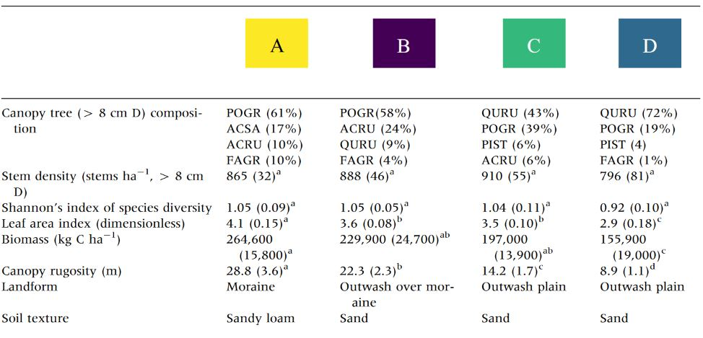

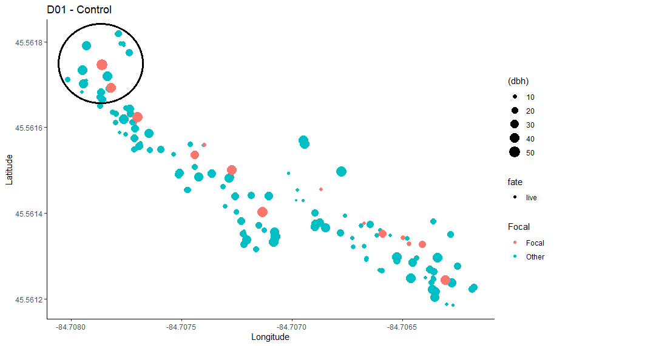

**Figure 1.3.** Stem map of the control (0 % girdled) plot in this study. Red circles represent focal trees while blue circles represent neighboring trees. The black circle represents the 10 m radius neighborhood for the westernmost focal tree in this plot. Similar 10 m radius neighborhoods will be constructed for each focal tree, but only one is drawn here for the sake of an uncluttered illustration.

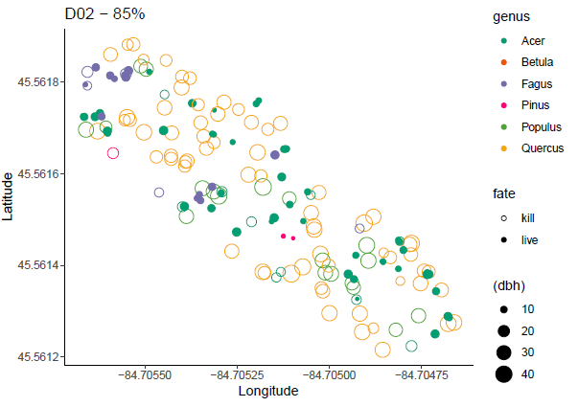

**Figure 1.4.** Stem map for the 85 % disturbed (i.e. highest disturbance severity) study area. This mapped region contains 17 focal trees (one of the original 18 was accidentally girdled in 2019) and their neighbors. Data visualized include tree genus, size class (as DBH) and fate (live or killed by girdling).

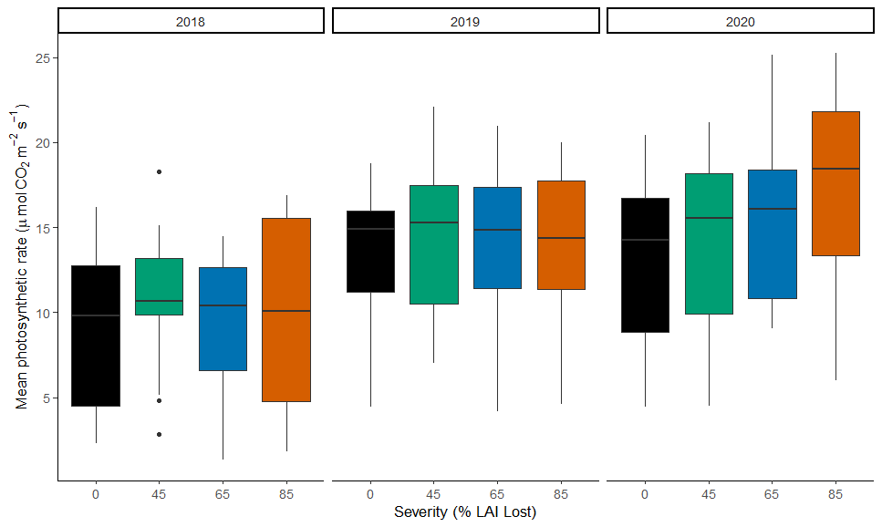

**Figure 1.5.** Asat distributions for canopy leaves in July 2018, 2019, and 2020, grouped by disturbance severity. Mean photosynthetic rate for all crowns, regardless of their neighborhood’s disturbance severity, increased from 2018 (pre-disturbance) to 2019 and 2020, likely due to the impacts of interannual climatic variation on growing season tree ecophysiology. Further statistical analysis is needed to investigate the interactive effects of year, disturbance severity, tree species, and neighborhood characteristics.

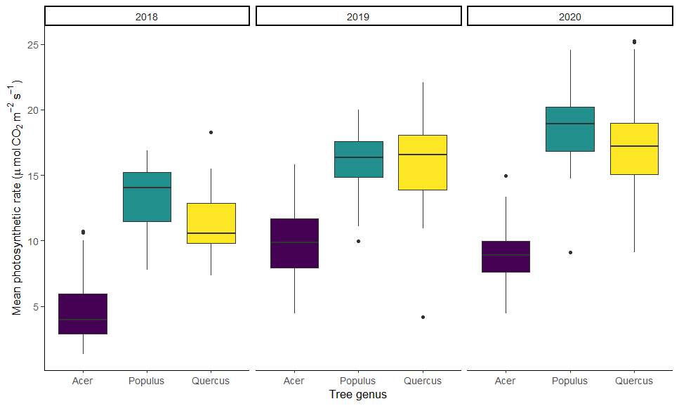

**Figure 1.6.** Light-saturated net CO2 assimilation (Asat)values for canopy leaves in July 2018, 2019, and 2020, grouped by tree genus (*Acer*, *Populus*, and *Quercus*) across all disturbance severities. In all three years, mean photosynthetic rate of red maple leaves (genus *Acer*) was lower than that of oaks or aspen, consistent with prior observations (Stuart-Haëntjens et al., 2015). As in Fig. 1.5, we see an uptick in physiology for all samples from 2018 to 2019 and 2020.

**Chapter 2**: *Subcanopy plant functional trait response to varying disturbance severity and implications for ecosystem-scale net primary production*

**2.1 Introduction**

Plant functional traits (i.e. measurable attributes of leaves, wood, and other tissues with relationships to whole-plant survival and growth) have been under study as potentially useful predictors of ecosystem function for decades (Zakharova et al., 2019). Functional traits of leaves reflect tradeoffs in the internal economics and resource allocation strategies of plants with important implications for ecosystem processes, including primary production (Serbin & Townsend, 2020; Westoby & Wright, 2006; Wright et al., 2004). Scaling functional traits from individuals or species up to communities or ecosystems is often accomplished through the use of *community-weighted means* (Lavorel et al., 2008), which take into account the relative abundances of species in a sample plot, community, or ecosystem. Community-weighted means (CWM) of leaf functional traits have been studied across a wide variety of environmental gradients, and have been tied to ecosystem net primary production in multiple ecosystem types (Finegan et al., 2015; Gustafsson & Norkko, 2019; Lavorel, 2013). However, generalizable patterns of CWM functional trait response to disturbance across variable ecosystems and gradients of severity remain elusive (Herben et al., 2018; Lai et al., 2020; Mcintyre et al., 1999).

Better characterization of CWM leaf functional trait response to disturbance is complicated by uncertainties in how variable ecosystem structure impacts leaf functional traits within canopies and across heterogeneous landscapes (Serbin & Townsend, 2020). Recent studies have investigated the use of remote sensing technologies to scale up localized CWM plant functional trait data sets to whole canopies (e.g. Kamoske et al., 2021) and landscapes (e.g. Abelleira Martínez et al., 2016). However, exploration of the linkages between disturbance-induced canopy structural change, including loss of canopy vegetative area, and CWM leaf functional traits in different forest strata is lacking. Filling this knowledge gap is important as disturbance-driven changes in ecosystem structure may contribute to differential ecosystem functional resilience, including net primary production (NPP) resilience, particularly across gradients of disturbance severity (Scheuermann et al., 2018). Improved understanding of the linkages between disturbance-altered ecosystem structure and resulting shifts in CWM leaf functional traits is important for predicting ecosystem functional recovery to disturbance (Funk et al., 2017; Serbin & Townsend, 2020).

At higher disturbance severities in which a majority of canopy-dominant trees senesce, subcanopy production becomes increasingly important to stabilizing ecosystem C cycling (Fahey et al., 2016; Stuart-Haëntjens et al., 2015). Therefore, particularly at the high end of the disturbance severity gradient, CWM subcanopy functional traits (i.e. leaf morphology, biochemistry, and physiology) may become critical predictors of sustained ecosystem-scale net primary production (NPP) (Grman et al., 2010; Polley et al., 2013). In this study, I will examine subcanopy CWM leaf functional trait response to disturbance across a gradient of disturbance severity, as well as across four landscape ecosystem types (i.e. experimental replicates) within the FoRTE manipulation (Pearsall et al., 1995). My aim will be to characterize changes in pre- to peak-disturbance CWM subcanopy leaf functional traits in order to determine whether this hypothetically important driver is correlated with differential ecosystem-scale subcanopy production response to disturbance at differing severities. The putative mechanism connecting canopy-targeted disturbance and subcanopy leaf functional response is altered canopy structure, driving changes in the subcanopy light and resource environment that, in turn, drive subcanopy CWM leaf traits. Therefore, I will use the extensive FoRTE canopy structure dataset in order to test this hypothetical relationship between changing canopy structure, subcanopy CWM leaf functional traits, and subcanopy ANPPw in the four years from pre- to peak disturbance.

**2.2 Objectives & Hypotheses:**

**O2.1:** Quantify the effect of disturbance severity (0, 45, 65, and 85 % gross defoliation) on subcanopy community-weighted means (CWM) of leaf traits (LMA, NDVIleaf, gs, Asat) across four landform types.

***H2.1:*** *Increases in subcanopy CWMs associated with sun-leaf morphology and physiology over three growing seasons after disturbance will positively correlate with disturbance severity; this effect will be most pronounced in low productivity sites.*

**O2.2:** Determine whether disturbance-altered canopy vegetative area index (VAI) relates to changes in subcanopy leaf functional trait CWMs with rising disturbance severity.

***H2.2:*** *High severity disturbance (i.e. loss of the majority of canopy leaves) will reduce canopy vegetative area, leading to increases in subcanopy light availability and more sun-adapted leaf functional trait CWMs.*

**O2.3:** Determine whether subcanopy CWM leaf functional traits correlate with ANPPw of the subcanopy stratumin the first three years following experimental disturbance.

***H2.3:*** *Immediately following disturbance, when impacts to the structure and function of the canopy are just beginning to manifest, subcanopy CWM leaf functional traits will not respond to disturbance. However, as the ecosystem enters the more dynamic period in years 2-3 following disturbance, higher subcanopy ANNPw will be observed at higher disturbance severities, reflecting a shift in CWM functional traits toward high light acclimation.*

**2.3 Methods:**

*2.3.1 Experimental design and site description*

This study is underway at the FoRTE disturbance manipulation, as described in detail in Chapter 1. Here, sampling occurs across all four experimental replicates, each located within a unique landscape ecosystem type according to the UMBS classification system (Kost et al., 2007; Pearsall et al., 1995; Fig. 1.1, Table 1.1). Within FoRTE, these distinct ecosystem types are referred to as experimental replicates A, B, C, and D. These replicates correspond to UMBS landscape ecosystem types 109 (mesic northern forest on moraine), 60 (mesic northern forest on outwash/moraine), 44 (dry-mesic northern forest on outwash plain), and 37 (dry-mesic northern forest on outwash plain), respectively.

According to Pearsall et al., these landscape ecosystems are the finest-scale “structural-functional units of nature” (p. 2), and are defined by different physiography, soil type/parent material, hydrology, and vegetation. For the purposes of this study, *landscape ecosystem* serves as the experimental blocking factor in the replicated disturbance treatment.

*2.3.2 Community-weighted mean subcanopy leaf functional traits*

Leaves at 1 to 2 m above the ground have been sampled from subcanopy trees across all four FoRTE experimental replicates, each located within a unique landscape ecosystem. Within each of thirty two 0.1 hectare subplots (Fig. 1.1B, circular subplots highlighted in gray inset image), leaves were selected from three different stems in each of four vegetation survey plots (Fig. 1.1B, squares in gray inset at intercardinal directions) for a total of 12 leaves per subplot. In some cases, a lack of available leaves at our sampled height necessitated selection of closest nearby leaves (from similar light conditions) from outside the vegetation survey plot boundaries. If sampled leaves failed to reach a stable photosynthetic rate, additional leaves were selected to achieve the minimum desired sample size of 12 per subplot, leading to a total 2019 sample size of 391 leaves. A subset of sampled stems was included in mapping that occurred in 2018 across all FoRTE subplots, though the majority were too small to have been included (i.e. DBH < 8 cm). In 2018, I flagged each branch directly beneath the understory leaves which had been sampled so that I could return to not only the same stems, but also the same individual branches for repeat sampling in 2019 and subsequent years.

The goal of subcanopy functional trait and physiological sampling in this study is to generate a set of CWM leaf functional trait values for each FoRTE subplot. Therefore, sampling took place in the standardized manner described above and did not target particular species. In order to assess whether my subcanopy sample accurately captures subcanopy species abundance across FoRTE (i.e. is a community-weighted sample) – and in the absence of available stem map data for this size class of tree – I compared species abundances in my sample with another independently collected subcanopy stem sample from FoRTE (Grigri et al., 2020). As can be seen in Table 2.1, our samples compared well across replicates, with especially strong correspondence in replicates A and B (where the subcanopy is less heterogeneous and more dominated by *Fagus grandifolia* saplings). In all replicates across both samples, the top three species (in terms of abundance) were in agreement, though their exact rankings and abundances varied. It is important to note that despite some differences in species abundances across these distinct FoRTE sampling efforts, CWMs have been found to have minimal sensitivity to methodological differences for computing species abundances and are even robust to methods based on visual estimation of abundance (Lavorel et al., 2008).

Functional traits of interest, each with well-established linkages to ecosystem-scale NPP, include light-saturated net CO2 assimilation rate (Asat), stomatal conductance (gs), leaf reflectance (used to derive NDVIleaf, a commonly used proxy for plant greenness and N content; Hansen & Schjoerring, 2003), and leaf mass per area (LMA). Each of these traits has been measured using the same methodologies and instruments described in Chapter 1. Importantly, due to incompatibility with the CI-710 miniature leaf spectrometer, pine needles (collected in some plots where pine saplings occurred in the sampling area) were omitted from the NDVIleaf data set.

*2.3.3 Canopy structure*

Multiple canopy structural metrics have been assessed in each FoRTE subplot on an annual or more frequent basis since 2018. These include leaf area index measured from litter traps and/or hemispherical imaging of the canopy, and a suite of portable canopy LiDAR-derived canopy structural complexity (CSC) metrics characterizing the arrangement and amount of canopy cover (Atkins et al., 2018) including vegetation area index (VAI). Mean VAI will be computed for each subplot in each year based on multiple transect measurements taken at full leaf-out; all data are available through the *fortedata* package in R (Atkins et al., 2021).

*2.3.4 Aboveground wood net primary production*

Aboveground wood net primary production (ANPPw) for the subcanopy stratum of the forest will be inferred from dendrometer bands installed on subcanopy size class (i.e. 1-8 cm DBH; (Grigri et al., 2020) trees across the FoRTE landscape, which directly measure woody biomass growth increment on a representative sample of trees. Since a primary interest in this study is to test the influence of disturbance-mediated subcanopy leaf functional change on ecosystem processes, the choice of subcanopy (rather than whole-canopy) ANPPw as the targeted ecosystem process outcome will allow for appropriate scaling within this single stratum. Moreover, prior work (including at our site; Stuart-Haëntjens et al., 2015) has shown that the subcanopy stratum is a critically important forest component in stabilizing C cycling following moderate severity disturbance. First-year post disturbance FoRTE subcanopy ANPPw data and analysis have already been published in Grigri et al. (2020) and this dataset continues to be built upon annually in FoRTE.

*2.3.5 Statistical analysis*

*Analysis O2.1:*

In order to test hypothesized linkages between disturbance severity and CWMs of leaf traits, I will employ a series of statistical models. All statistical analysis will be conducted in R using package *lme4* (Bates et al., 2015). First, this analysis must address the inherently hierarchical or nested nature of the data collected, including grouping of samples within geographically non-independent areas and repeated measurements through successive years of data collection. To address O2.1, I will use a time series split-plot mixed effects ANOVA similar in design to the published models used in analysis of first-year production response at our site (Gough et al., 2020; Grigri et al., 2020). In this model, disturbance severity (0, 45, 65, or 85 %) will be the fully randomized whole-plot factor, while disturbance treatment (“bottom-up” or “top-down” disturbance application, described in section 1.3, and randomized within each disturbance severity level) is the restrictively randomized split-plot factor (see Fig. 1.2 for illustration of this design). This statistical model is detailed in Equation 2.1 and Table 2.2 below:

(2.1)

Where Yijkl is the normally distributed subplot-level CWM subcanopy leaf functional trait, µ is the grand mean, Repi is experimental replicate (a random effect, analogous to an experimental block), Yearj is the sample year (*j* indexing the timeframe 2018-2021), Severityk|i is the disturbance severity (with each severity level, *k*, randomized within the *i*th replicate), Typel is the treatment type (*l* indexing one of the two types, top-down or bottom-up), two interaction terms for year*severity and year*type, and four separate error terms (three within-group error terms to deal with nested effects, plus a residual error term). For simplicity’s sake, all error terms are lumped in the notation in Equation 2.1 (as term ε), but are detailed in Table 2.2 as they will be separately analyzed in this model. To compare means across modeled groups, I will perform LSD post hoc pairwise tests with α = 0.05.

*Analysis O2.2:*

To examine whether canopy structure across the FoRTE landscape drives differential subcanopy leaf functional traits (O2.2), I will follow two steps. First, I will test whether canopy vegetative area index (VAI) is related to disturbance severity, type, and year. To accomplish this, I will use an identical model to that outlined in Equation 2.1, with my outcome variable (Yijkl) as VAI. All other parameters (i.e. the entire right-hand side of the equation) will be the same as previously described.

Once I have tested the relationship between disturbance, year, and VAI, I will then proceed to address the core of O2.2. This objective seeks to determine whether disturbance-altered canopy structure – regardless of landform type/experimental replicate, or interannual climatic variability – relates to subcanopy CWM leaf functional traits across FoRTE as disturbance has unfolded. To answer this question, I will use a series of linear mixed effect models following the general form described in Equation 2.2 below:

(2.2)

Where yi is the vector of N observations of the outcome variable; xi and zi are design matrices for the fixed and random effects, respectively; is the vector of fixed parameters; ui is the vector of random parameters; is the vector of residuals; and Ri is the variance-covariance matrix for the error term.

In my analysis, normally-distributed CWM leaf functional traits will be the outcome, while normally-distributed VAI, year, and the interaction of VAI and year will be the predictors. VAI is a fixed effect and will have a regression coefficient of interest, while year and its interaction term with VAI are random effects (reflecting the unpredictability of interannual climatic differences that impact canopy structure and other variables). The goal of this modeling effort is to determine whether, after accounting for random interannual variability, there is a significant relationship between canopy VAI and subcanopy CWM leaf traits. Full models (including the interaction term) will be fit initially and contrasted with simpler models (excluding the interaction term). The best candidate model (i.e. with the lowest AIC score) will be chosen as the final model for each CWM. All models will be fit using the ‘lmer’ function from R package *lme4* (Bates et al., 2015), using restricted maximum likelihood criteria. Equation 2.3 below gives this model:

(2.3)

Where Yi is the *i*th subplot’s CWM leaf functional trait (Asat, NDVI, LMA, or gs), is the global intercept, is the regression coefficient for VAI, VAIi is the subplot level mean vegetative area index, Yeari is a random effect term for year (2018-2021), VAI*Yeari is the interaction between VAI and year, and is the residual error term.

*Analysis O2.3:*

To address O2.3, asking whether subcanopy ANPPw is predicted by community weighted mean leaf functional traits, I will use generalized linear mixed effects models to account for the skewed nature of ANPPw, which naturally follows a non-Gaussian distribution across heterogeneous forested landscapes such as FoRTE. In these models, the outcome variable will be annual woody NPP for each subplot, and the predictors will be the continuous variables of CWM functional traits (those found to vary significantly with disturbance in the analysis for O2.1) and disturbance severity, and the random effect of year. Since I hypothesize an interaction between severity and year such that the impacts of disturbance will not initially manifest in changed subcanopy NPP, I also include this interaction term. These models will follow the form provided in Equation 2.4 below:

(2.4)

Where Yi is the *i*th subplot’s yearly ANPPw, beta terms are coefficients, CWMi is the leaf functional trait (Asat, NDVI, LMA, or gs), Sevi is disturbance severity, CWM*Sevi is the fixed effect interaction between the CWM functional trait and severity, Yeari is a random effect term for year (2018-2021), Sev*Yeari is the random effect interaction of disturbance severity with year, and epsilon is the residual error term.

**2.4** **Progress to date**

Three years’ worth of data have been collected to date, with a final season of data collection scheduled in summer 2021. Preliminary data visualization in the form of boxplots is provided for several key variables in figures below, though formal statistical analysis is still pending.

Figure 2.1 illustrates CWM subcanopy leaf Asat at peak leaf-out across the four disturbance severities in 2018, 2019, and 2020. Substantial interannual variation in CWM leaf physiology is evident, though higher disturbance severity may be yielding a hypothesized increase in CWM leaf photosynthetic rate in 2020.

Figure 2.2, showing the distributions of subplot mean VAI across the disturbance severity gradient in 2018-2020, similarly suggests substantial interannual variability in canopy vegetative area. Differences in means for VAI across disturbance severities appear to be slight in 2020 (one year post-disturbance). However, the anticipated peak disturbance in 2021 is expected to yield much larger differences as crowns fully deteriorate in response to girdling.

Figure 2.3 shows a single year of subcanopy ANPPw for 2020. (ANPPw data for different forest strata were also collected in 2019, but have not yet been visualized for the subcanopy. Seedling/sapling stem diameter measurements and dendrometer band data will also be collected in summer 2021.) Intriguingly, visual inspection suggests that though these distributions are highly skewed across the FoRTE landscape and across disturbance severities, the hypothesized uptick in ANPPw hypothesized at higher disturbance severities may be unfolding following disturbance.

**2.5 Figures and Tables**

**Table 2.1.** Comparison of independently sampled subcanopy tree species compositions in FoRTE replicates in 2018. Agreement between data sets (i.e. subcanopy percent composition and rankings of species by abundance) was strongest in replicates A and B where unfolding beech bark disease-driven proliferation of beech sprouts dominates the subcanopy in experimental plots. While there was weaker agreement in the more heterogeneous C and D replicates, the same three subcanopy tree species together accounted for the majority of stems in in both samples from these replicates.

|  |  |  |  |
| --- | --- | --- | --- |
| Replicate / landscape ecosystem | Tree species | Percent subcanopy composition in 2018 | |
| Haber (this study) | (Grigri et al., 2020) |
| A / mesic forest | *Fagus grandifolia* | 55 | 49 |
| *Acer pensylvanicum* | 41 | 42 |
| *Acer saccharum* | 3 | 4 |
| ***TOTAL*** | ***99*** | ***95*** |
| B / mesic forest | *Fagus grandifolium* | 63 | 42 |
| *Acer pensylvanicum* | 19 | 13 |
| *Acer rubrum* | 11 | 24 |
| ***TOTAL*** | ***93*** | ***79*** |
| C / dry-mesic forest | *Fagus grandifolia* | 42 | 19 |
| *Acer pensylvanicum* | 27 | 18 |
| *Pinus strobus* | 19 | 41 |
| ***TOTAL*** | ***88*** | ***78*** |
| D / dry-mesic forest | *Pinus strobus* | 35 | 53 |
| *Acer rubrum* | 29 | 33 |
| *Fagus grandifolia* | 25 | 8 |
| ***TOTAL*** | ***89*** | ***94*** |

**Table 2.2.** Partial ANOVA table (model parameters and degrees of freedom) for time series split-plot ANOVA model detailed in equation 2.1. The total sample size of community weighted mean values for leaf physiological data across 32 subplots and 4 years is *n* = 128.

|  |  |
| --- | --- |
| *Parameter* | *Model DF* |
| Experimental replicate | 3 |
| Year | 3 |
| Error 1 (replicate*year) | 9 |
| Disturbance type | 1 |
| Error 2 (replicate*type) | 3 |
| Year*type | 3 |
| Error 3 (replicate*year*type) | 9 |
| Disturbance severity | 3 |
| Year*severity | 9 |
| Residual error | 84 |
| TOTAL | 127 |

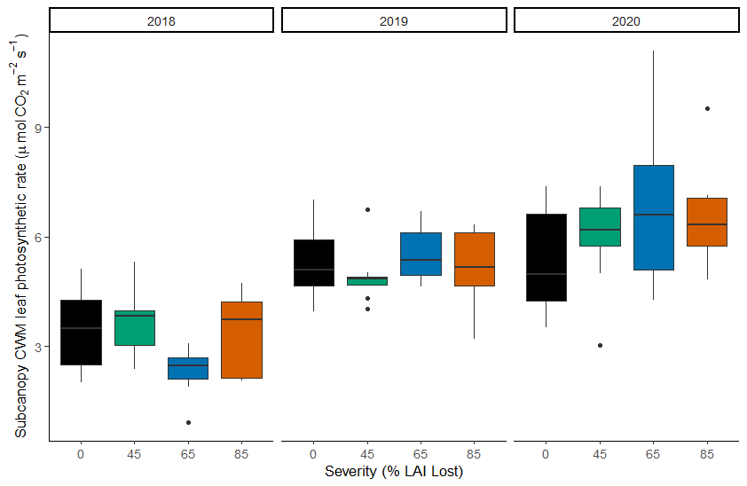

**Figure 2.1.** Subcanopy community-weighted mean (CWM) leaf photosynthetic rate across differing disturbance severity levels in the years 2018 – 2020.

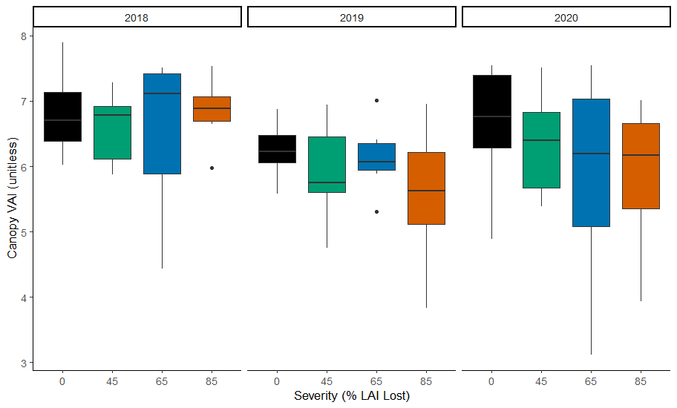

**Figure 2.2.** Vegetative area index for subplots across the FoRTE landscape, grouped by disturbance severity, for years 2018-2020. The boxplots illustrate substantial interannual variation in canopy vegetative area, as well as potential declines at higher disturbance severities through time.

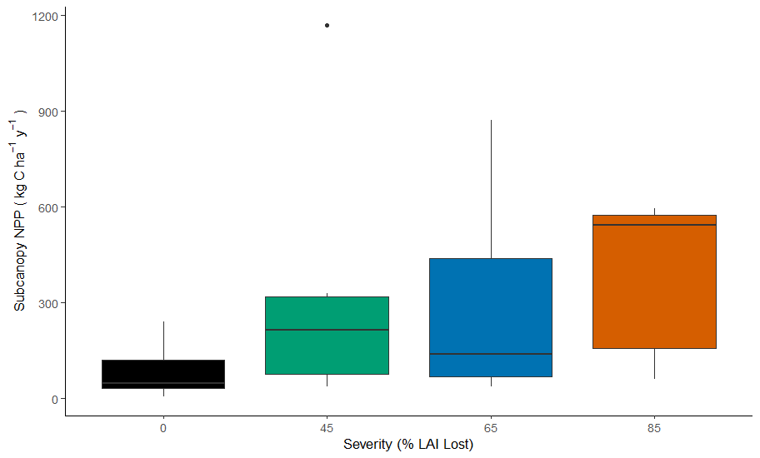

**Figure 2.3.** Subcanopy aboveground wood net primary production (ANPPw) across the four experimental disturbance severities for the year 2020.

**Chapter 3:** *What level of model complexity is needed to accurately predict initial carbon cycling responses to disturbance?: A coupled field-model experiment*

**3.1 Introduction**

The variable ways in which ecological disturbances occur may have profoundly different impacts on ecosystem carbon (C) cycling (Wales et al., 2020), yet different disturbance types are not well distinguished in current ecosystem models (Bond-Lamberty et al., 2015; Dietze & Matthes, 2014). Forest disturbances unfold across gradients of tree mortality, duration, frequency, and degree of impact to specific biomass pools and C cycling processes, each with poorly characterized but potentially distinct functional consequences (Anderegg et al., 2015; Dietze & Matthes, 2014). In particular, the impacts of moderate severity disturbances, including those caused by insect and pathogen outbreaks, are not well incorporated into ecosystem models (Bond-Lamberty et al., 2015; Dietze & Matthes, 2014). This lack of realistic representation in models makes it difficult to probe the potential array of ecosystem C cycling responses under different disturbance scenarios, particularly as disturbance interacts with ecological succession (Hicke et al., 2012).

Field experiments executed in tandem with modeling exercises (“model-data fusion experiments”) offer a unique opportunity to improve model performance by leveraging targeted data collection to both appropriately parameterize models and rigorously assess their accuracy and uncertainty (Raupach et al., 2005). Recent model-data fusion work within the FoRTE project has indicated that greater model uncertainty in projections of net primary production (NPP) following stand-replacing disturbance arises from inadequately constrained vegetation parameter values than from model structure (Shiklomanov et al., 2020). Importantly, these site-specific results indicate that future efforts to improve model accuracy in response to disturbance should focus on field data collection of influential model parameters. Two leaf functional traits (the maximum rate of carboxylation, Vcmax; and leaf mass per area, LMA), as well as the ecosystem-scale leaf area index (LAI), are examples of model parameters that are influential to predictions of NPP (Luo et al., 2004; Walker et al., 2014), responsive to disturbance, and also highly variable among sites and ecosystems (Louault et al., 2005). One of the aims of this study is to assess whether site-specific values for these functional traits substantially improve model predictions over PFT default values.

Another important consideration in evaluating ecosystem models is the trade-off between model complexity and ecological realism, on the one hand, and computational time and impediments to general use, on the other (Fisher et al., 2018). It is therefore of interest to identify models that have sufficient, but not excessive, complexity to accurately simulate observed C cycling outcomes and trends. In this study, I will use a simple ecosystem model (SEM) with explicit incorporation of a phloem flux disruption (i.e. same disturbance mechanism as experimental girdling), published by Dietze & Matthes (2014) in a proof-of-concept study modeling different forest insect and pathogen disturbance types, to simulate C cycling response to disturbance within our experimental forest. I will then compare this model’s output, using a set of common benchmarks, with that recently generated by a colleague using a far more complex ecosystem model (the Ecosystem Demography Model version 2.2, or “ED2”; (Medvigy et al., 2009) to simulate a disturbance across an identical severity gradient at our FoRTE field site (Dorheim et al., in prep.). ED2 is a terrestrial biosphere model that incorporates physical, hydrological, biogeochemical, and vegetation demographic components to project land-atmosphere C, H2O and energy exchanges as well as vegetation change through time. Both the SEM and ED2 use the same underlying representation of ecophysiology, including photosynthesis and C fluxes; what this study will test is whether a simple model, with explicit incorporation of a phloem flux disruption but excluding many of the parameters and computational cost of ED2, in particular with respect to light transmission and cohort dynamics, is sufficient to capture short-term C cycling responses to disturbance in our forest. If this simplified and freely accessible model – which is available on GitHub and can be run with minimal computing requirements – is adequate for predicting disturbance C cycling responses of interest, the implications for the broader ecosystem C cycle science community may include increased direct engagement with ecosystem modeling. Finally, to answer my question about the impacts of model parameter choice, I will perform a sensitivity analysis of targeted parameter values to determine their impact on SEM outcomes.

**3.2 Objectives & Hypotheses:**

**O3.1:** Determine whether a simple ecosystem model (SEM) with specific representation of phloem-disrupting disturbance can accurately forecast C cycling responses to disturbance (often simulated using far more complex models), and compare outcomes with the more structurally complex ED2 model (which lacks a specific phloem-flux disruption mechanism) using woody biomass increment, LAI, and NPP as common benchmarks.

***H3.1:*** *Both the SEM and ED2 employ common structural elements, but only the SEM allows for implementation of a targeted disruption to phloem C flux. The models fundamentally differ in their treatment of ecosystem processes such as growth and light transmission, with ED2 having far more complex implementation for these and other features. Although neither model may fully simulate observed disturbance-induced changes in C cycling in FoRTE, especially at lower severities (Bond-Lamberty et al., 2015), the added complexity of ED2 may not improve model skill at simulating FoRTE C dynamics. The SEM will perform as well as ED2 in simulating responses in biomass increment, LAI, and NPP at our site over the first 3 years following disturbance because the SEM incorporates sufficient explanation of production-related outcomes due to phloem-flux disruption.*

**O3.2:** Analyze the SEM’s sensitivity to disturbance-sensitive parameter values (LMA, quantum yield, and Vcmax) and determine whether site-specific functional trait distributions improve model performance over PFT defaults.

***H3.2:*** *Although several of these model parameters are well constrained for the plant functional types represented at our site (including LMA and Vcmax; Shiklomanov et al., 2020), leaf functional traits also exhibit a high degree of inter- as well as intraspecific plasticity (Henn et al., 2018; Messier et al., 2010; Violle et al., 2012) and are known to be sensitive to disturbance (Stuart-Haëntjens et al., 2015). Therefore, model outputs for biomass increment, LAI, and NPP will be improved by the use of site-specific trait values that more precisely capture trait distributions at our site.*

**3.3 Methods:**

*3.3.1 Experimental summary and model parameterization*

I will use a modified version of the previously published simple ecosystem model (SEM) including a phloem disruption disturbance from Dietze & Matthes (2014) to run 3-year post-disturbance C cycling simulations for our FoRTE site (described previously in Ch. 1). This model was built to simulate functional outcomes when different major forest biomass pools (stems, leaves, and roots) and transport tissues (xylem and phloem) are disrupted from disturbance (Fig. 3.1). The SEM has previously been tested using a young, even-aged ponderosa pine stand and a single year’s worth of meteorological data from an AmeriFlux tower in central Oregon (US-Me2). In this prior proof-of-concept study, the authors excluded the complicating effects of phenology, species diversity, heterogeneous canopy structure, and interannual climatic variability. In order to generate a realistic disturbance simulation for our site, I will use a more representative stand including size-class and species diversity. The model will be driven with site-specific climatic data (collected at the primary UMBS AmeriFlux tower, US-UMB). To test model sensitivity to PFT vs. site-specific parameter values, I will run paired models using default PFT functional trait means from the TRY database (Kattge et al., 2011) and leaf functional data collected from our experimental site and compare outcomes.

The SEM employs a similar ecophysiological framework as ED2, including the underlying photosynthetic equations (Farquhar et al., 1980; Medlyn et al., 2011) and component C fluxes. This will enable a meaningful comparison between the SEM output and that of an ED2 ensemble run that colleague Kalyn Dorheim (at Pacific Northwest National Laboratory) has recently generated in another FoRTE-centered modeling study. Direct comparison, using common benchmarks (detailed below), of the simplified model and the vastly more complex one – both attempting to simulate the same disturbance – will inform us as to whether a simple model can perform as well as a complex one at this task.

*3.3.2 Field data collection*

FoRTE field data collection efforts span a wide array of ecosystem structural and functional characteristics. Data sets used in model benchmarking (described in greater detail below) include net primary production (NPP) and woody biomass increment (both estimated through deployment of stem dendrometer bands on a subset of trees), and leaf area index (LAI, estimated through litter trap leaf collection and scaling). Leaf functional trait data sets used in variable parameterization for SEM sensitivity analysis (O3.2) include leaf mass per area (LMA) and photosynthetic measurements including (but perhaps not limited to) the quantum yield of photosynthesis and the maximum rate of carboxylation (Vcmax). I have a published large data set (*n* = 79; Haber et al., 2020) of quantum yield values for understory leaves of multiple tree species within the UMBS FASET disturbance manipulation in 2016 that can be leveraged for site-specific, post-disturbance trait parameterization. Vcmax is expected to be a critically important term to capture, and values for this parameter were estimated at UMBS in 1999 in the AmeriFlux forest for four canopy dominant tree species representing both early- and mid-successional PFTs.

*3.3.3 Benchmarking and model comparison*

Benchmarking for comparison between the SEM and ED2 model outputs (O3.1) will leverage existing data sets from years 0-3 of disturbance within FoRTE, capturing dynamic changes in NPP, LAI, and woody biomass increment. Modeled values for 3-year post-disturbance changes in these variables will be compared to observational data, enabling comparison of model performance. We will examine not only the differences in magnitude of these specific C cycle components across disturbance severities and disturbance types at the site, but also differences in timing (years 1-3) of an ecosystem “crash” (i.e. an unraveling of ecosystem resilience).

**3.4 Progress to date**

I am working to build out an R package that FoRTE collaborators Kalyn Dorheim and Ben Bond-Lamberty initiated in 2020 allowing for implementation of this modeling project as well as adaptation and reuse by future researchers. To date, the package contains the original SEM model published by Dietze & Matthes (2014) and has been used to run simple model iterations with non-site-specific parameter values and climate forcing data.

**3.5 Figures**

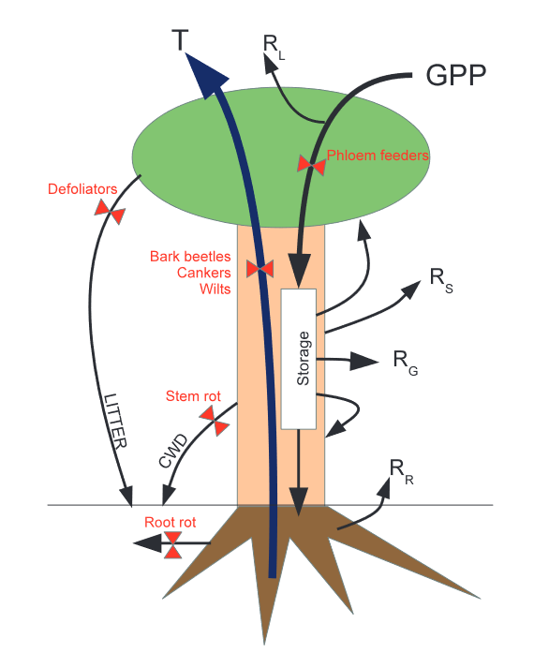

**Figure 3.1.** Schematic diagram borrowed directly from Dietze & Matthes (2014) illustrating the component C fluxes represented in their simple ecosystem model (black arrows) and the five different biotic disturbance types (red valves and text) they incorporated. This experiment will use the built-in mechanism for phloem disruption (i.e. the type of disturbance induced in FoRTE via stem-girdling), illustrated here as alteration of the flux from leaves (site of gross primary production, GPP, less the maintenance costs of leaves via respiration, RL) to storage elsewhere in the tree, primarily in roots.

**Chapter 4:** *Ecosystem functional recovery following disturbance: carbon dynamics of a restored tidal freshwater wetland*

*Foreword:* *In the final chapter of this dissertation, I will explore ecosystem functional recovery following disturbance in a different ecosystem type and using a different observational platform. My previous chapters have investigated the role of leaf functional traits in underpinning functional resilience to disturbance at tree neighborhood to landscape scales, as well as the sensitivity of ecosystem model prediction to parameterization of these traits. Here, I will employ eddy covariance technology to assess ecosystem-scale C dynamics following disturbance in a recovering tidal freshwater wetland in Virginia. In this chapter, I will scale up from leaf traits to the “green smear” of vegetation within the study footprint, and from leaf-level gas flux measurements to ecosystem land-atmosphere exchange. While differing from previous chapters in scale, methodology, and ecosystem type, this study is thematically integrated as an examination of post-disturbance recovery of ecosystem C cycling dynamics.*

**4.1 Introduction**

Wetland carbon (C) dynamics, including carbon dioxide (CO2) and methane (CH4) emissions, remain a critical area of uncertainty in global greenhouse gas budgets (Bloom et al., 2017; Nahlik & Fennessy, 2016). Freshwater mineral soil wetlands, including tidal freshwater wetlands (TFWs), are the largest source of uncertainty in current estimates of North American wetland C cycling even as these wetlands are thought to comprise the largest global fraction of wetland CH4 flux and contribute significantly to atmospheric radiative forcing (Bridgham et al., 2006, 2013). The biophysical controls on TFW C cycling are complex and vary across a range of physical and environmental gradients. Further complicating robust determination of radiative forcing (often computed as “global warming potential”) contributed by TFWs is their proclivity to disturbance across broad scales of frequency and severity (Mitsch & Gosselink, 2007). Moreover, many of these systems are currently impaired and/or carry the legacies of past disturbance (*ibid.*), prompting a growing interest in ecological restoration of wetlands (Baldwin et al., 2018; Zedler & Kercher, 2005).

As the ecological movement to restore wetlands intensifies, there is lingering uncertainty about their capacity to recover ecosystem – including C cycling – function (Zedler, 2000). A recent review of TFW restoration in North America and Europe (Baldwin et al., 2018) indicates that restoration of these systems can produce structural and functional analogues of natural systems, but that much remains unknown about the pace and ultimate scale of recovery following restoration efforts. Knowledge gaps emerging from prior studies of C cycling processes in TFWs undergoing restoration include: does restoration of TFWs “restore” ecosystem functions governing atmosphere-biosphere CH4 and CO2 exchange following disturbance (Baldwin et al., 2018)? What are the relevant ecological and environmental drivers and time scales for functional recovery (Anderson et al., 2016; Herbst et al., 2011)? And, how does concurrent sea level rise and changing salinity in TFWs interact with restoration efforts to alter their function (Neubauer et al., 2013)? Coupled CO2 and CH4 flux data sets have rarely been measured in TFWs undergoing ecological restoration (Petrescu et al., 2015). Constraining the biophysical controls on C fluxes is essential for evaluating the radiative forcing of TFWs, and understanding the contributions that aggrading, “restored” TFWs make to C emissions is necessary to improve prediction of C cycling in ecosystem models (*ibid.*).

In this study, I propose to assess the biophysical drivers of CO2 and CH4 fluxes within the Rice Rivers Center’s Kimages Creek restored wetland on timescales of hours, days, and months from dormant season to peak growing season. Kimages Creek is a unique site (US-RRC) within the AmeriFlux network, where it has been included since 2017. This study would leverage the existing eddy covariance tower infrastructure at the site, as well as ancillary data collected within the tower footprint, to characterize the biophysical effects on the direction, magnitude, and partitioning of CO2 and CH4 fluxes within an aggrading, restored forested wetland. Earlier work at this site (by Ellen Stuart-Haentjens, VCU ILS PhD candidate) has examined soil C stocks and fluxes using *in situ* chamber flux and gas chromatograph-derived measurements. However, drivers of fluxes at timescales of hours up to a full growing season remain poorly characterized for this underrepresented system within the global flux network, and additional work is needed in order to fully understand C cycling impacts and global warming potential of this system.

**4.2 Objectives and Hypotheses:**

**O4.1:** Quantify hourly to monthly land-atmosphere exchange and radiative forcing of targeted C compounds (CO2, CH4) within the Kimages Creek restored wetland’s eddy covariance flux tower footprint from end of growing season 2021 to peak growing season 2022 (September, 2021 – July, 2022).

***H4.1:*** *Land-atmosphere exchange of CO2 and CH4 within Kimages Creek will exhibit daily and seasonal signals differing in both magnitude and direction. CO2 flux will exhibit a strong seasonal signal with a change in sign from the dormant season (positive, i.e. net emissons) to the growing season (negative, i.e. uptake; Bonneville et al., 2008). CH4 flux will remain positive year-round from the tower footprint (based on chamber flux measurements; Stuart-Haentjens,* in prep.*) but will increase in summer due to rising soil and water temperatures and increased transport through the aerenchyma of wetland plants (Anderson et al., 2016). CO2 flux will exhibit an hourly-to-diurnal pattern during the growing season corresponding with irradiance and photosynthetic activity (Neubauer et al., 2000) while CH4 flux will also demonstrate hourly and diurnal variability, with an added driver of tidal forcing (Holm et al., 2016). Overall, the restored wetland will contribute net positive radiative forcing through emitted carbon, following a pattern observed in other disturbed and subsequently restored wetlands (Neubauer, 2014).*

**O4.2:** Determine the primary biophysical drivers of hourly, daily, and seasonal landscape-scale fluxes of CO2 and CH4 in a restored wetland.

***H4.2:*** *The primary biophysical drivers of CO2 fluxes will be seasonally variable, including irradiance and plant greenness (driving photosynthesis, i.e. CO2 uptake), and soil temperature (driving respiration, i.e. CO2 release; Neubauer et al., 2000). CH4 will be dominated by different seasonal environmental (soil and water temperature) and hourly (tidally-determined variation in soil H2O and O2 content) drivers (Rey-Sanchez et al., 2018; White et al., 2008). Additionally, transport through herbaceous plant tissues (*Zizania aquatica *and others) will constitute a major driver of CH4 release across the landscape (Brix et al., 1992; Garnet et al., 2005), but this will correspond with irradiance as daytime stomatal opening allows methane release (Neubauer et al., 2000).*

**4.3 Methods:**

*4.3.1 Study site*

The proposed study will take place at the VCU Rice Rivers Center in Charles City County, VA. The Center contains a 70-acre wetland spanning a tidal freshwater creek (Kimages Creek) at its mouth in the Lower James River and is the site of a wetland restoration project under conservation easement with the Nature Conservancy. The formerly bottomland hardwood forested site (once dominated by bald cypress, *Taxodium distichum*) has experienced repeated disturbance since the Civil War era and most recently in the 1920s, when the wetland was cut over and an earthen dam and spillway was constructed at the mouth of Kimages Creek to create a lake for a boys’ camp. The dam was removed in order to restore tidal exchange and wetland hydrology in 2010, and native grasses, shrubs, and trees have been planted on site to encourage vegetative recovery. At present, the site is dominated by a mix of southern wild rice (*Zizania aquatica*) and other herbaceous wetland plants, with sapling black willow (*Salix nigra*) and bald cypress (Taxodium distichum) trees also interspersed as part of the restoration planting. An eddy covariance flux tower was installed on the site in 2015, and locations for ancillary data collection (including deployment of pressure transducers) in the tower footprint have also been established by Ellen Stuart-Haentjens for prior research.

*4.3.2 Net ecosystem exchange & tower-based meteorological measurements*

The eddy covariance flux tower hosts instrumentation for collecting a suite of gas exchange and meteorological measurements (including photosynthetically active irradiance, air temperature, 3D wind direction, wind speed, and concentrations of gases of interest) at a frequency of 10 Hz, as well as a modem for transmitting data in real time. LI-7500A CO2 and LI-7700 CH~~4~~ analyzers (LI-COR Biosciences, Lincoln, NE) will measure raw gas concentrations, while available software (LI-COR’s EddyPro and SMARTFlux) will enable corrected half-hourly fluxes.

*4.3.3 Belowground measurements & tidal flux*

Because the degree of soil inundation exerts strong controls on wetland soil biogeochemistry, including CO2 and CH4 exchange, it will be important to capture the changing soil water content due to both tidal flux and large precipitation events using an array of four pressure transducers (HOBO 13’ depth water level data loggers, Onset Computer Corporation, Bourne, MA) within the tower footprint sampling at 5 minute intervals. Soil temperature will be measured simultaneously by the HOBO data loggers in order to constrain this important biogeochemical driver (Mitsch & Gosselink, 2007). Established wells for these sensors have already been created and mapped by Stuart-Haentjens, enabling continuity of data collection.

*4.3.4 Estimation of canopy greenness and phenology*

Canopy greenness is a useful ecosystem-scale indicator of plant photosynthetic activity through time and an important biophysical driver of wetland C cycling. As part of a recently awarded DOE grant to Oikawa et al. (co-PI Chris Gough), a Phenocam will soon be installed at the tower site for collecting high temporal resolution canopy greenness data. If this instrument cannot be installed in time for continuous flux data collection initiation this fall, I will instead use cloud-free Landsat 8 scenes (with 30 m x 30 m pixel resolution) encompassing the tower footprint to assess canopy greenness through time at two fixed locations within the tower footprint. Greenness will be computed as the normalized difference vegetation index (NDVI) following standard procedures using Landsat 8 spectral bands (Pan et al., 2018).

*4.3.4 Data gap filling and flux modeling*

Eddy-covariance data sets frequently include gaps in observations resulting from a variety of factors, including meteorological conditions failing to satisfy key assumptions of EC theory (i.e. insufficiently turbulent atmospheric conditions), power supply issues, and dirty or malfunctioning sensors. This study will apply the commonly used gap filling technique of artificial neural networks, or ANN, which have been found to outperform other gap filling methods for carbon fluxes (Moffat et al., 2007; Rey-Sanchez et al., 2018). ANNs are trained to use site-level environmental variables known to drive components of land-atmosphere carbon exchange to develop empirical models of CO2 and CH4 fluxes and ecosystem respiration (Re). Where local (i.e. tower-affixed) meteorological data are unavailable, data from a neighboring meteorological tower located at the Rice Rivers Center will be used.

*4.3.5 Statistical analysis and assessment of radiative forcing*

Tidally-driven water depth, soil temperature, canopy greenness, aboveground meteorological variables, and irradiance will be included in multilinear regression analyses to determine which of these predictors have the largest influence on modeled CO2 and CH4 fluxes. Statistical analysis will follow established methods used in similar, recently published studies investigating the primary drivers of NEE and methane fluxes in freshwater wetlands (Morin et al., 2014; Rey-Sanchez et al., 2018; Waldo et al., 2021). Forward stepwise multivariate linear modeling will be performed with sequential addition of predictor variables and the models with the lowest AIC scores will be retained as the best candidate model of ecosystem-scale CO2 and CH4 fluxes.

To quantify and enable comparison of the radiative forcing and global warming potential contributed by each gas – and to determine the radiative balance of the Kimages Creek restored tidal wetland, i.e. source or sink for these greenhouse gases – I will modify the approach of Neubauer & Megonigal (2015) for computation of the global warming potential of ecosystems. I will model cumulative radiative forcing contributed by each gas under the assumptions of sustained annual fluxes, differential atmospheric residence times, and potency as greenhouse gases, for fixed time periods (10, 20, and 50 years). Using an established modeling framework will not only enable a robust analysis of this system’s radiative balance, but also allow for preliminary comparison with other wetland systems (with the important limitation that this analysis will be based on less than one year’s worth of flux data).

**4.4 Progress to date**

A number of technical issues since 2018 and lack of stable funding have delayed the initiation of continuous, usable flux data collection from this tower site. I secured funds in fall 2020 to initiate instrument repairs and replacement of defunct tower components, some of which have taken an unusually long time to complete due to COVID-related delays in repair processing and shipment. In good news, nearly all components have been returned and are ready to deploy in fall 2021. In even better news, co-PI Chris Gough, Ellen Stuart-Haentjens and others were recently awarded a DOE grant that secures funding for tower support and maintenance beginning in September, 2021.

**References**

Abelleira Martínez, O. J., Fremier, A. K., Günter, S., Ramos Bendaña, Z., Vierling, L., Galbraith, S. M., Bosque-Pérez, N. A., & Ordoñez, J. C. (2016). Scaling up functional traits for ecosystem services with remote sensing: concepts and methods. In *Ecology and Evolution* (Vol. 6, Issue 13, pp. 4359–4371). John Wiley and Sons Ltd. https://doi.org/10.1002/ece3.2201

Addicott, J. F., Aho, J. M., Antolin, M. F., Padilla, D. K., Richardson, J. S., & Soluk, D. A. (1987). Ecological neighborhoods: scaling environmental patterns. *Oikos*, *49*, 340–346.

Ali, H. E., Reineking, B., & Münkemüller, T. (2017). Effects of plant functional traits on soil stability: intraspecific variability matters. *Plant and Soil*, *411*(1–2), 359–375. https://doi.org/10.1007/s11104-016-3036-5

Amiro, B. D., Barr, A. G., Barr, J. G., Black, T. A., Bracho, R., Brown, M., Chen, J., Clark, K. L., Davis, K. J., Desai, A. R., Dore, S., Engel, V., Fuentes, J. D., Goldstein, A. H., Goulden, M. L., Kolb, T. E., Lavigne, M. B., Law, B. E., Margolis, H. A., … Xiao, J. (2010). Ecosystem carbon dioxide fluxes after disturbance in forests of North America. *Journal of Geophysical Research: Biogeosciences*, *115*(4). https://doi.org/10.1029/2010JG001390

Anderegg, W. R. L., Hicke, J. A., Fisher, R. A., Allen, C. D., Aukema, J., Bentz, B., Hood, S., Lichstein, J. W., Macalady, A. K., Mcdowell, N., Pan, Y., Raffa, K., Sala, A., Shaw, J. D., Stephenson, N. L., Tague, C., & Zeppel, M. (2015). Tree mortality from drought, insects, and their interactions in a changing climate. *New Phytologist*, *208*(3), 674–683. https://doi.org/10.1111/nph.13477

Anderson, F. E., Bergamaschi, B., Sturtevant, C., Knox, S., Hastings, L., Windham-Myers, L., Detto, M., Hestir, E. L., Drexler, J., Miller, R. L., Matthes, J. H., Verfaillie, J., Baldocchi, D., Snyder, R. L., & Fujii, R. (2016). Variation of energy and carbon fluxes from a restored temperate freshwater wetland and implications for carbon market verification protocols. *Journal of Geophysical Research: Biogeosciences*, *121*(3), 777–795. https://doi.org/10.1002/2015JG003083

Atkins, J. W., Agee, E., Barry, A., Dahlin, K. M., Dorheim, K., Grigri, M. S., Haber, L. T., Hickey, L. J., Kamoske, A. G., Mathes, K., McGuigan, C., Paris, E., Pennington, S. C., Rodriguez, C., Shafer, A., Shiklomanov, A., Tallant, J., Gough, C. M., & Bond-Lamberty, B. (2021). The fortedata R package: open-science datasets from a manipulative experiment testing forest resilience. *Earth System Science Data*, *13*(3), 943–952. https://doi.org/10.5194/essd-13-943-2021

Atkins, J. W., Bohrer, G., Fahey, R. T., Hardiman, B. S., Morin, T. H., Stovall, A. E. L., Zimmerman, N., & Gough, C. M. (2018). Quantifying vegetation and canopy structural complexity from terrestrial LiDAR data using the forestr r package. *Methods in Ecology and Evolution*, *9*(10), 2057–2066. https://doi.org/10.1111/2041-210X.13061

Baldwin, A. H., Hammerschlag, R. S., & Cahoon, D. R. (2018). Evaluating restored tidal freshwater wetlands. In *Coastal Wetlands: An Integrated Ecosystem Approach* (pp. 889–912). Elsevier. https://doi.org/10.1016/B978-0-444-63893-9.00025-3

Banner, K. M., Irvine, K. M., & Rodhouse, T. J. (2020). The use of Bayesian priors in Ecology: The good, the bad and the not great. In *Methods in Ecology and Evolution* (Vol. 11, Issue 8, pp. 882–889). British Ecological Society. https://doi.org/10.1111/2041-210X.13407

Bates, D., Mächler, M., Bolker, B. M., & Walker, S. C. (2015). Fitting linear mixed-effects models using lme4. *Journal of Statistical Software*, *67*(1). https://doi.org/10.18637/jss.v067.i01

Bernhardt-Römermann, M., Gray, A., Vanbergen, A. J., Bergès, L., Bohner, A., Brooker, R. W., de Bruyn, L., de Cinti, B., Dirnböck, T., Grandin, U., Hester, A. J., Kanka, R., Klotz, S., Loucougaray, G., Lundin, L., Matteucci, G., Mészáros, I., Oláh, V., Preda, E., … Stadler, J. (2011). Functional traits and local environment predict vegetation responses to disturbance: A pan-European multi-site experiment. *Journal of Ecology*, *99*(3), 777–787. https://doi.org/10.1111/j.1365-2745.2011.01794.x

Bloom, A., Bowman, W. K., Lee, M., Turner, J. A., Schroeder, R., Worden, R. J., Weidner, R., McDonald, C. K., & Jacob, J. D. (2017). A global wetland methane emissions and uncertainty dataset for atmospheric chemical transport models (WetCHARTs version 1.0). *Geoscientific Model Development*, *10*(6), 2141–2156. https://doi.org/10.5194/gmd-10-2141-2017

Bond-Lamberty, B., Fisk, J. P., Holm, J. A., Bailey, V., Bohrer, G., & Gough, C. M. (2015). Moderate forest disturbance as a stringent test for gap and big-leaf models. *Biogeosciences*, *12*, 513–526. https://doi.org/10.5194/bg-12-513-2015

Bonneville, M. C., Strachan, I. B., Humphreys, E. R., & Roulet, N. T. (2008). Net ecosystem CO2 exchange in a temperate cattail marsh in relation to biophysical properties. *Agricultural and Forest Meteorology*, *148*(1), 69–81. https://doi.org/10.1016/j.agrformet.2007.09.004

Bridgham, S. D., Cadillo-Quiroz, H., Keller, J. K., & Zhuang, Q. (2013). Methane emissions from wetlands: Biogeochemical, microbial, and modeling perspectives from local to global scales. *Global Change Biology*, *19*(5), 1325–1346. https://doi.org/10.1111/gcb.12131

Bridgham, S. D., Megonigal, J. P., Keller, J. K., Bliss, N. B., & Trettin, C. (2006). The carbon balance of North American wetlands. *Wetlands*, *26*(4), 889–916. https://doi.org/10.1672/0277-5212(2006)26[889:TCBONA]2.0.CO;2

Brix, H., Sorrel, B. K., & Orr, P. T. (1992). Internal pressurization and convective gas flow in some emergent freshwater macrophytes. In *Limnol. Oceanogr* (Vol. 37, Issue 7).

Cardinale, B. J., Duffy, J. E., Gonzalez, A., Hooper, D. U., Perrings, C., Venail, P., Narwani, A., MacE, G. M., Tilman, D., Wardle, D. A., Kinzig, A. P., Daily, G. C., Loreau, M., Grace, J. B., Larigauderie, A., Srivastava, D. S., & Naeem, S. (2012). Biodiversity loss and its impact on humanity. *Nature*, *486*(7401), 59–67. https://doi.org/10.1038/nature11148

Cohen, W. B., Yang, Z., Stehman, S. v., Schroeder, T. A., Bell, D. M., Masek, J. G., Huang, C., & Meigs, G. W. (2016). Forest disturbance across the conterminous United States from 1985-2012: The emerging dominance of forest decline. *Forest Ecology and Management*. https://doi.org/10.1016/j.foreco.2015.10.042

Connell, J. H. (1978). Diversity in Tropical Rain Forests and Coral Reefs. *Science*, *199*(4335), 1302–1310. http://www.jstor.org/stable/1745369

DeMalach, N., Zaady, E., Weiner, J., & Kadmon, R. (2016). Size asymmetry of resource competition and the structure of plant communities. *Journal of Ecology*, *104*(4), 899–910. https://doi.org/10.1111/1365-2745.12557

Dietze, M. C., & Matthes, J. H. (2014). A general ecophysiological framework for modelling the impact of pests and pathogens on forest ecosystems. *Ecology Letters*. https://doi.org/10.1111/ele.12345

Fahey, R. T., Stuart-Haëntjens, E. J., Gough, C. M., de La Cruz, A., Stockton, E., Vogel, C. S., & Curtis, P. S. (2016). Evaluating forest subcanopy response to moderate severity disturbance and contribution to ecosystem-level productivity and resilience. *Forest Ecology and Management*. https://doi.org/10.1016/j.foreco.2016.06.001

Fan, C., Tan, L., Zhang, C., Zhao, X., Gao, L., & von Gadow, K. (2020). Scale-dependent effects of neighborhood biodiversity on individual tree productivity in a coniferous and broad-leaved mixed forest in China. *Ecology and Evolution*, *10*(15), 8225–8234. https://doi.org/10.1002/ece3.6530

Fargione, J., Tilman, D., Dybzinski, R., Lambers, J. H. R., Clark, C., Harpole, W. S., Knops, J. M. H., Reich, P. B., & Loreau, M. (2007). From selection to complementarity: Shifts in the causes of biodiversity-productivity relationships in a long-term biodiversity experiment. *Proceedings of the Royal Society B: Biological Sciences*, *274*(1611), 871–876. https://doi.org/10.1098/rspb.2006.0351

Farquhar, G. D., von Caemmerer, S., & Berry, J. A. (1980). A biochemical model of photosynthetic CO2 assimilation in leaves of C3 species. *Planta*, *149*, 78–90.

Finegan, B., Peña-Claros, M., de Oliveira, A., Ascarrunz, N., Bret-Harte, M. S., Carreño-Rocabado, G., Casanoves, F., Díaz, S., Eguiguren Velepucha, P., Fernandez, F., Licona, J. C., Lorenzo, L., Salgado Negret, B., Vaz, M., & Poorter, L. (2015). Does functional trait diversity predict above-ground biomass and productivity of tropical forests? Testing three alternative hypotheses. *Journal of Ecology*, *103*(1), 191–201. https://doi.org/10.1111/1365-2745.12346

Fisher, R. A., Koven, C. D., Anderegg, W. R. L., Christoffersen, B. O., Dietze, M. C., Farrior, C. E., Holm, J. A., Hurtt, G. C., Knox, R. G., Lawrence, P. J., Lichstein, J. W., Longo, M., Matheny, A. M., Medvigy, D., Muller-Landau, H. C., Powell, T. L., Serbin, S. P., Sato, H., Shuman, J. K., … Moorcroft, P. R. (2018). Vegetation demographics in Earth System Models: A review of progress and priorities. *Global Change Biology*. https://doi.org/10.1111/gcb.13910

Fortin, M.-J., & Dale, M. R. T. (2005). *Spatial Analysis : A Guide for Ecologists*. Cambridge University Press.

Frelich, L. E., Sugita, S., Reich, P. B., Davis, M. B., & Friedman, S. K. (1998). Neighbourhood Effects in Forests: Implications for within-Stand Patch Structure. In *Source: Journal of Ecology* (Vol. 86, Issue 1).

Funk, J. L., Larson, J. E., Ames, G. M., Butterfield, B. J., Cavender-Bares, J., Firn, J., Laughlin, D. C., Sutton-Grier, A. E., Williams, L., & Wright, J. (2017). Revisiting the Holy Grail: Using plant functional traits to understand ecological processes. *Biological Reviews*, *92*(2), 1156–1173. https://doi.org/10.1111/brv.12275

Garnet, K. N., Megonigal, J. P., Litchfield, C., & Taylor, G. E. (2005). Physiological control of leaf methane emission from wetland plants. *Aquatic Botany*, *81*(2), 141–155. https://doi.org/10.1016/j.aquabot.2004.10.003

Garnier, E., Navas, M.-L., & Grigulis, K. (2016). *Plant Functional Diversity: Organism traits, community structure, and ecosystem properties* (First ed.). Oxford Scholarship Online. https://doi.org/10.1093/acprof:oso/9780198757368.001.0001

Gough, C. M., Atkins, J. W., Bond-Lamberty, B., Agee, E. A., Dorheim, K. R., Fahey, R. T., Grigri, M. S., Haber, L. T., Mathes, K. C., Pennington, S. C., Shiklomanov, A. N., & Tallant, J. M. (2020). Forest Structural Complexity and Biomass Predict First-Year Carbon Cycling Responses to Disturbance. *Ecosystems*. https://doi.org/10.1007/s10021-020-00544-1

Gough, C. M., Hardiman, B. S., Nave, L. E., Bohrer, G., Maurer, K. D., Vogel, C. S., Nadelhoffer, K. J., & Curtis, P. S. (2013). Sustained carbon uptake and storage following moderate disturbance in a Great Lakes forest. *Ecological Applications*. https://doi.org/10.1890/12-1554.1

Grigri, M. S., Atkins, J. W., Vogel, C., Bond-Lamberty, B., & Gough, C. M. (2020). Aboveground wood production is sustained in the first growing season after phloem-disrupting disturbance. *Forests*, *11*(12), 1–19. https://doi.org/10.3390/f11121306

Grman, E., Lau, J. A., Schoolmaster, D. R., & Gross, K. L. (2010). Mechanisms contributing to stability in ecosystem function depend on the environmental context. *Ecology Letters*, *13*(11), 1400–1410. https://doi.org/10.1111/j.1461-0248.2010.01533.x

Grossiord, C. (2019). Having the right neighbors: how tree species diversity modulates drought impacts on forests. *New Phytologist*. https://doi.org/10.1111/nph.15667

Gustafsson, C., & Norkko, A. (2019). Quantifying the importance of functional traits for primary production in aquatic plant communities. *Journal of Ecology*, *107*(1), 154–166. https://doi.org/10.1111/1365-2745.13011

Haddad, N. M., Holyoak, M., Mata, T. M., Davies, K. F., Melbourne, B. A., & Preston, K. (2008). Species’ traits predict the effects of disturbance and productivity on diversity. *Ecology Letters*, *11*(4), 348–356. https://doi.org/10.1111/j.1461-0248.2007.01149.x

Hansen, P. M., & Schjoerring, J. K. (2003). Reflectance measurement of canopy biomass and nitrogen status in wheat crops using normalized difference vegetation indices and partial least squares regression. *Remote Sensing of Environment*, *86*(4), 542–553. https://doi.org/10.1016/S0034-4257(03)00131-7

Hardiman, B. S., Gough, C. M., Butnor, J. R., Bohrer, G., Detto, M., & Curtis, P. S. (2017). Coupling fine-scale root and canopy structure using ground-based remote sensing. *Remote Sensing*, *9*(2). https://doi.org/10.3390/rs9020182

Henn, J. J., Buzzard, V., Enquist, B. J., Halbritter, A. H., Klanderud, K., Maitner, B. S., Michaletz, S. T., Pötsch, C., Seltzer, L., Telford, R. J., Yang, Y., Zhang, L., & Vandvik, V. (2018). Intraspecific trait variation and phenotypic plasticity mediate alpine plant species response to climate change. *Frontiers in Plant Science*, *871*. https://doi.org/10.3389/fpls.2018.01548

Herben, T., Klimešová, J., & Chytrý, M. (2018). Effects of disturbance frequency and severity on plant traits: An assessment across a temperate flora. *Functional Ecology*, *32*(3), 799–808. https://doi.org/10.1111/1365-2435.13011

Herbst, M., Friborg, T., Ringgaard, R., & Soegaard, H. (2011). Interpreting the variations in atmospheric methane fluxes observed above a restored wetland. *Agricultural and Forest Meteorology*, *151*(7), 841–853. https://doi.org/10.1016/j.agrformet.2011.02.002

Hicke, J. A., Allen, C. D., Desai, A. R., Dietze, M. C., Hall, R. J., Hogg, E. H. T., Kashian, D. M., Moore, D., Raffa, K. F., Sturrock, R. N., & Vogelmann, J. (2012). Effects of biotic disturbances on forest carbon cycling in the United States and Canada. *Global Change Biology*. https://doi.org/10.1111/j.1365-2486.2011.02543.x

Hillebrand, H., Langenheder, S., Lebret, K., Lindström, E., Östman, Ö., & Striebel, M. (2017). Decomposing multiple dimensions of stability in global change experiments. *Ecology Letters*. https://doi.org/10.1111/ele.12867

Holm, G. O., Perez, B. C., McWhorter, D. E., Krauss, K. W., Johnson, D. J., Raynie, R. C., & Killebrew, C. J. (2016). Ecosystem Level Methane Fluxes from Tidal Freshwater and Brackish Marshes of the Mississippi River Delta: Implications for Coastal Wetland Carbon Projects. *Wetlands*, *36*(3), 401–413. https://doi.org/10.1007/s13157-016-0746-7

Hooten, M. B., Hobbs, N. T., & Ellison, A. M. (2015). A guide to Bayesian model selection for ecologists. *Ecological Monographs*. https://doi.org/10.1890/14-0661.1

Johnstone, J. F., Allen, C. D., Franklin, J. F., Frelich, L. E., Harvey, B. J., Higuera, P. E., Mack, M. C., Meentemeyer, R. K., Metz, M. R., Perry, G. L. W., Schoennagel, T., & Turner, M. G. (2016). Changing disturbance regimes, ecological memory, and forest resilience. *Frontiers in Ecology and the Environment*. https://doi.org/10.1002/fee.1311

Kamoske, A. G., Dahlin, K. M., Serbin, S. P., & Stark, S. C. (2021). Leaf traits and canopy structure together explain canopy functional diversity: an airborne remote sensing approach. *Ecological Applications*, *31*(2). https://doi.org/10.1002/eap.2230

Kattge, J., Díaz, S., Lavorel, S., Prentice, I. C., Leadley, P., Bönisch, G., Garnier, E., Westoby, M., Reich, P. B., Wright, I. J., Cornelissen, J. H. C., Violle, C., Harrison, S. P., van Bodegom, P. M., Reichstein, M., Enquist, B. J., Soudzilovskaia, N. A., Ackerly, D. D., Anand, M., … Wirth, C. (2011). TRY - a global database of plant traits. *Global Change Biology*, *17*(9), 2905–2935. https://doi.org/10.1111/j.1365-2486.2011.02451.x

Kost, M. A., Albert, D. A., Cohen, J. G., Slaughter, B. S., Schillo, R. K., Weber, C. R., Chapman, K. A., Albert, D. A., Cohen, J. G., Slaughter, B. S., Schillo, R. K., Weber, C. R., & Chapman, K. A. (2007). *Natural Communities of Michigan: Classification and Description* (Vol. 314).

Kumordzi, B. B., Aubin, I., Cardou, F., Shipley, B., Violle, C., Johnstone, J., Anand, M., Arsenault, A., Bell, F. W., Bergeron, Y., Boulangeat, I., Brousseau, M., de Grandpré, L., Delagrange, S., Fenton, N. J., Gravel, D., Macdonald, S. E., Hamel, B., Higelin, M., … Munson, A. D. (2019). Geographic scale and disturbance influence intraspecific trait variability in leaves and roots of North American understorey plants. *Functional Ecology*, *33*(9), 1771–1784. https://doi.org/10.1111/1365-2435.13402

Lai, H. R., Chong, K. Y., Yee, A. T. K., Tan, H. T. W., & van Breugel, M. (2020). Functional traits that moderate tropical tree recruitment during post-windstorm secondary succession. *Journal of Ecology*, *108*(4), 1322–1333. https://doi.org/10.1111/1365-2745.13347

Lavorel, S. (2013). Plant functional effects on ecosystem services. In *Journal of Ecology* (Vol. 101, Issue 1, pp. 4–8). https://doi.org/10.1111/1365-2745.12031

Lavorel, S., Grigulis, K., McIntyre, S., Williams, N. S. G., Garden, D., Dorrough, J., Berman, S., Quétier, F., Thébault, A., & Bonis, A. (2008). Assessing functional diversity in the field - Methodology matters! In *Functional Ecology* (Vol. 22, Issue 1, pp. 134–147). Blackwell Publishing Ltd. https://doi.org/10.1111/j.1365-2435.2007.01339.x

Louault, F., Pillar, V., Aufrère, J., Garnier, E., & Soussana, J.-F. (2005). Plant traits and functional types in response to reduced disturbance in a semi-natural grassland. *Journal of Vegetation Science*, *16*, 151–160.

Luo, T., Pan, Y., Ouyang, H., Shi, P., Luo, J., Yu, Z., & Lu, Q. (2004). Leaf Area Index and Net Primary Productivity along Subtropical to Alpine Gradients in the Tibetan Plateau. *Global Ecology and Biogeography*, *13*(4), 345–358.

Mcintyre, S., Lavorel, S., Landsberg, J., & Forbes, T. D. A. (1999). Disturbance Response in Vegetation: Towards a Global Perspective on Functional Traits. In *Source: Journal of Vegetation Science* (Vol. 10, Issue 5).

Medlyn, B. E., Duursma, R. A., Eamus, D., Ellsworth, D. S., Prentice, I. C., Barton, C. V. M., Crous, K. Y., de Angelis, P., Freeman, M., & Wingate, L. (2011). Reconciling the optimal and empirical approaches to modelling stomatal conductance. *Global Change Biology*, *17*(6), 2134–2144. https://doi.org/10.1111/j.1365-2486.2010.02375.x

Medvigy, D., Wofsy, S. C., Munger, J. W., Hollinger, D. Y., & Moorcroft, P. R. (2009). Mechanistic scaling of ecosystem function and dynamics in space and time: Ecosystem Demography model version 2. *Journal of Geophysical Research: Biogeosciences*. https://doi.org/10.1029/2008JG000812

Meinzer, F. C., Lachenbruch, B., & Dawson, T. E. (2011). *Size-and age-related changes in tree structure and function*. Springer.

Messier, J., McGill, B. J., & Lechowicz, M. J. (2010). How do traits vary across ecological scales? A case for trait-based ecology. *Ecology Letters*, *13*(7), 838–848. https://doi.org/10.1111/j.1461-0248.2010.01476.x

Mitsch, W. J., & Gosselink, J. G. (2007). *Wetlands* (4th ed.). Wiley.

Moffat, A. M., Papale, D., Reichstein, M., Hollinger, D. Y., Richardson, A. D., Barr, A. G., Beckstein, C., Braswell, B. H., Churkina, G., Desai, A. R., Falge, E., Gove, J. H., Heimann, M., Hui, D., Jarvis, A. J., Kattge, J., Noormets, A., & Stauch, V. J. (2007). Comprehensive comparison of gap-filling techniques for eddy covariance net carbon fluxes. *Agricultural and Forest Meteorology*, *147*(3–4), 209–232. https://doi.org/10.1016/j.agrformet.2007.08.011

Morin, T. H., Bohrer, G., Frasson, R. P. D. M., Naor-Azreli, L., Mesi, S., Stefanik, K. C., & Schäfer, K. V. R. (2014). Environmental drivers of methane fluxes from an urban temperate wetland park. *Journal of Geophysical Research G: Biogeosciences*, *119*(11), 2188–2208. https://doi.org/10.1002/2014JG002750

Mouillot, D., Graham, N. A. J., Bastien Villé Ger, S., Mason, N. W. H., & Bellwood, D. R. (2013). A functional approach reveals community responses to disturbances. *Trends in Ecology & Evolution*, *28*(3), 167–177. https://doi.org/10.1016/j.tree.2012.10.004

Nahlik, A. M., & Fennessy, M. S. (2016). Carbon storage in US wetlands. *Nature Communications*, *7*, 13835. https://doi.org/10.1038/ncomms13835

Nave, L. E., Gough, C. M., Maurer, K. D., Bohrer, G., Hardiman, B. S., le Moine, J., Munoz, A. B., Nadelhoffer, K. J., Sparks, J. P., Strahm, B. D., Vogel, C. S., & Curtis, P. S. (2011). Disturbance and the resilience of coupled carbon and nitrogen cycling in a north temperate forest. *Journal of Geophysical Research: Biogeosciences*. https://doi.org/10.1029/2011JG001758

Neubauer, S. C., Franklin, R. B., & Berrier, D. J. (2013). Saltwater intrusion into tidal freshwater marshes alters the biogeochemical processing of organic carbon. *Biogeosciences*, *10*(12), 8171–8183. https://doi.org/10.5194/bg-10-8171-2013

Neubauer, Scott C. (2014). On the challenges of modeling the net radiative forcing of wetlands: Reconsidering Mitsch et al. 2013. *Landscape Ecology*, *29*(4), 571–577. https://doi.org/10.1007/s10980-014-9986-1

Neubauer, Scott C., & Megonigal, J. P. (2015). Moving Beyond Global Warming Potentials to Quantify the Climatic Role of Ecosystems. *Ecosystems*, *18*(6), 1000–1013. https://doi.org/10.1007/s10021-015-9879-4

Neubauer, Scott C, Miller, W. D., & Anderson, I. C. (2000). Carbon cycling in a tidal freshwater marsh ecosystem: a carbon gas flux study. *Marine Ecoogy Progress Series*, *199*, 13–30.

Pan, F., Xie, J., Lin, J., Zhao, T., Ji, Y., Hu, Q., Pan, X., Wang, C., & Xi, X. (2018). Evaluation of climate change impacts on wetland vegetation in the Dunhuang Yangguan National Nature Reserve in northwest China using landsat derived NDVI. *Remote Sensing*, *10*(5). https://doi.org/10.3390/rs10050735

Paquette, A., & Messier, C. (2011). The effect of biodiversity on tree productivity: from temperate to boreal forests. *Global Ecology and Biogeography*, *20*(1), 170–180. http://www.jstor.org/stable/41058230

Pearsall, D., Barnes, B., Zogg, G., Lapin, M., & Ring, R. (1995). *Landscape ecosystems of the University of Michigan Biological Station*.

Petrescu, A. M. R., Lohila, A., Tuovinen, J. P., Baldocchi, D. D., Desai, A. R., Roulet, N. T., Vesala, T., Dolman, A. J., Oechel, W. C., Marcolla, B., Friborg, T., Rinne, J., Matthes, J. H., Merbold, L., Meijide, A., Kiely, G., Sottocornola, M., Sachs, T., Zona, D., … Cescatti, A. (2015). The uncertain climate footprint of wetlands under human pressure. *Proceedings of the National Academy of Sciences of the United States of America*, *112*(15), 4594–4599. https://doi.org/10.1073/pnas.1416267112

Polley, H. W., Isbell, F. I., & Wilsey, B. J. (2013). Plant functional traits improve diversity-based predictions of temporal stability of grassland productivity. *Oikos*, *122*(9), 1275–1282. https://doi.org/10.1111/j.1600-0706.2013.00338.x

Rademacher, T. T., Basler, D., Eckes-Shephard, A. H., Fonti, P., Friend, A. D., le Moine, J., & Richardson, A. D. (2019). Using Direct Phloem Transport Manipulation to Advance Understanding of Carbon Dynamics in Forest Trees. *Frontiers in Forests and Global Change*, *2*. https://doi.org/10.3389/ffgc.2019.00011

Raupach, M. R., Rayner, P. J., Barrett, D. J., Defries, R. S., Heimann, M., Ojima, D. S., Quegan, S., & Schmullius, C. C. (2005). Model-data synthesis in terrestrial carbon observation: Methods, data requirements and data uncertainty specifications. *Global Change Biology*, *11*(3), 378–397. https://doi.org/10.1111/j.1365-2486.2005.00917.x

Rey-Sanchez, A. C., Morin, T. H., Stefanik, K. C., Wrighton, K., & Bohrer, G. (2018). Determining total emissions and environmental drivers of methane flux in a Lake Erie estuarine marsh. *Ecological Engineering*. https://doi.org/10.1016/j.ecoleng.2017.06.042

Schafer, K. V. R., Renninger, H. J., Carlo, N. J., & Vanderklein, D. W. (2014). Forest response and recovery following disturbance in upland forests of the Atlantic Coastal Plain. *Frontiers in Plant Science*, *5*. https://doi.org/10.3389/fpls.2014.00294

Scheuermann, C. M., Nave, L. E., Fahey, R. T., Nadelhoffer, K. J., & Gough, C. M. (2018). Effects of canopy structure and species diversity on primary production in upper Great Lakes forests. *Oecologia*. https://doi.org/10.1007/s00442-018-4236-x

Serbin, S. P., & Townsend, P. A. (2020). Scaling Functional Traits from Leaves to Canopies. In J. Cavender-Bares, J. A. Gamon, & P. A. Townsend (Eds.), *Remote Sensing of Plant Biodiversity* (pp. 43–82). Springer International Publishing. https://doi.org/10.1007/978-3-030-33157-3_3

Shiklomanov, A. N., Bond-Lamberty, B., Atkins, J. W., & Gough, C. M. (2020). Structure and parameter uncertainty in centennial projections of forest community structure and carbon cycling. *Global Change Biology*, *26*(11), 6080–6096. https://doi.org/10.1111/gcb.15164

Sousa, W. P. (1984). The Role of Disturbance in Natural Communities. *Annual Review of Ecology and Systematics*, *15*, 353–391. https://doi.org/10.1146/annurev.es.15.110184.002033

Stuart-Haëntjens, E. J., Curtis, P. S., Fahey, R. T., Vogel, C. S., & Gough, C. M. (2015). Net primary production of a temperate deciduous forest exhibits a threshold response to increasing disturbance severity. *Ecology*, *96*(9), 2478–2487. https://doi.org/10.1890/14-1810.1

Thom, D., & Seidl, R. (2016). Natural disturbance impacts on ecosystem services and biodiversity in temperate and boreal forests. *Biological Reviews of the Cambridge Philosophical Society*. https://doi.org/10.1111/brv.12193

Turner, M. G., Baker, W. L., Peterson, C. J., & Peet, R. K. (1998). Factors Influencing Succession: Lessons from Large, Infrequent Natural Disturbances. *Ecosystems*, *1*, 511–523.

Uriarte, M., Canham, C. D., Thompson, J., & Zimmerman, J. K. (2004). *A Neighborhood Analysis of Tree Growth and Survival in a Hurricane-Driven Tropical Forest* (Vol. 74, Issue 4).

Violle, C., Enquist, B. J., McGill, B. J., Jiang, L., Albert, C. H., Hulshof, C., Jung, V., & Messier, J. (2012). The return of the variance: Intraspecific variability in community ecology. *Trends in Ecology and Evolution*, *27*(4), 244–252. https://doi.org/10.1016/j.tree.2011.11.014

Waldo, S., Beaulieu, J., Barnett, W., Balz, D., Vanni, M., Williamson, T., & Walker, J. (2021). Temporal patterns and biophysical controls on methane emissions from a small eutrophic reservoir: insights from two years of eddy covariance monitoring. *Biogeosciences Discussions*, 1–40. https://doi.org/10.5194/bg-2021-36

Wales, S. B., Kreider, M. R., Atkins, J., Hulshof, C. M., Fahey, R. T., Nave, L. E., Nadelhoffer, K. J., & Gough, C. M. (2020). Stand age, disturbance history and the temporal stability of forest production. *Forest Ecology and Management*, *460*, 117865. https://doi.org/10.1016/J.FORECO.2020.117865

Walker, A. P., Beckerman, A. P., Gu, L., Kattge, J., Cernusak, L. A., Domingues, T. F., Scales, J. C., Wohlfahrt, G., Wullschleger, S. D., & Woodward, F. I. (2014). The relationship of leaf photosynthetic traits - Vcmax and Jmax - to leaf nitrogen, leaf phosphorus, and specific leaf area: A meta-analysis and modeling study. *Ecology and Evolution*, *4*(16), 3218–3235. https://doi.org/10.1002/ece3.1173

Westoby, M., & Wright, I. J. (2006). Land-plant ecology on the basis of functional traits. In *Trends in Ecology and Evolution*. https://doi.org/10.1016/j.tree.2006.02.004

White, J. R., Shannon, R. D., Weltzin, J. F., Pastor, J., & Bridgham, S. D. (2008). Effects of soil warming and drying on methane cycling in a northern peatland mesocosm study. *Journal of Geophysical Research: Biogeosciences*, *113*(3). https://doi.org/10.1029/2007JG000609

Wolter, P. T., & White, M. A. (2002). Recent forest cover type transitions and landscape structural changes in northeast Minnesota, USA. *Landscape Ecology*, *17*, 133–155. https://doi.org/10.1023/A:1016522509857

Wright, I. J., Reich, P. B., Westoby, M., Ackerly, D. D., Baruch, Z., Bongers, F., Cavender-Bares, J., Chapin, T., Cornelissen, J. H. C., Diemer, M., Flexas, J., Garnier, E., Groom, P. K., Gulias, J., Hikosaka, K., Lamont, B. B., Lee, T., Lee, W., Lusk, C., … Villar, R. (2004). The worldwide leaf economics spectrum. *Nature*, *428*, 821–827. https://doi.org/https://doi.org/10.1038/nature02403

Yang, H., Yang, X., Heskel, M., Sun, S., & Tang, J. (2017). Seasonal variations of leaf and canopy properties tracked by ground-based NDVI imagery in a temperate forest. *Scientific Reports*, *7*(1). https://doi.org/10.1038/s41598-017-01260-y

Zakharova, L., Meyer, K. M., & Seifan, M. (2019). Trait-based modelling in ecology: A review of two decades of research. In *Ecological Modelling* (Vol. 407). Elsevier B.V. https://doi.org/10.1016/j.ecolmodel.2019.05.008

Zedler, J. (2000). Progress in wetland restoration ecology. *Trends in Ecology and Evolution*, *15*(10), 402–407.

Zedler, J. B., & Kercher, S. (2005). WETLAND RESOURCES: Status, Trends, Ecosystem Services, and Restorability. *Annual Review of Environment and Resources*, *30*(1), 39–74. https://doi.org/10.1146/annurev.energy.30.050504.144248